GPS Locales

ADD001 =
9°00'44.3"N 38°43'47.9"E
9.012297, 38.729965

ADD002 =
9°00'45.6"N 38°43'47.6"E
9.012659, 38.729879

ADD003 =
9°00'44.3"N 38°43'47.4"E
9.012305, 38.729841

Particle Photon Board Nodes

Required Software

Particle has extensive documentation so I’d encourage you to check out their official documentation (Command Line Interface) https://docs.particle.io/guide/tools-and-features/cli/photon/ or community at https://community.particle.io/

Download both Python (https://www.python.org/downloads/) and Anaconda (https://www.anaconda.com/download/) as Particle will need these libraries in its command line actions.
(Make sure the python and anaconda file libraries are accessible within your command line file path.)
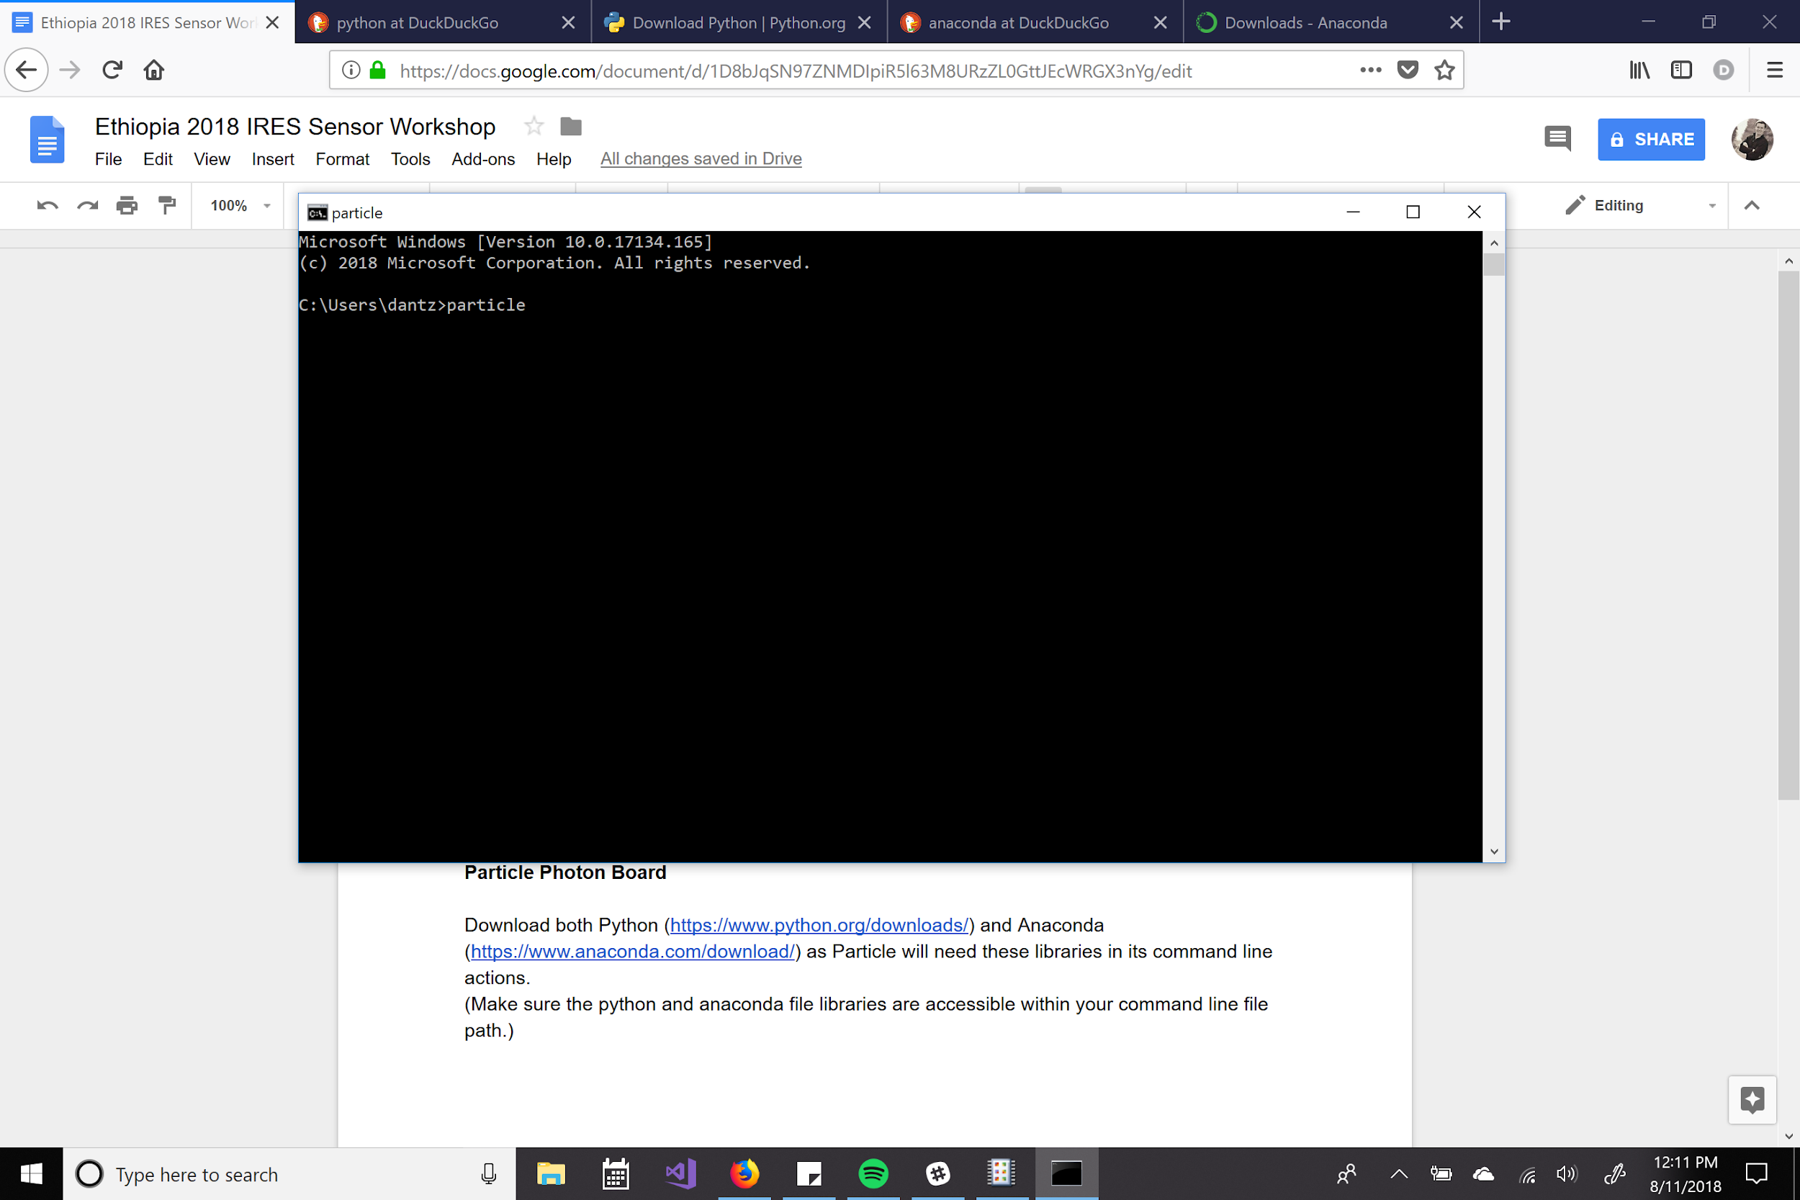
Make sure the python and anaconda libraries are within your filepath. Here, it is C:\Users\dantz

Make sure OpenSSL is within your filepath as well (used for generating keys when you setup the particle)
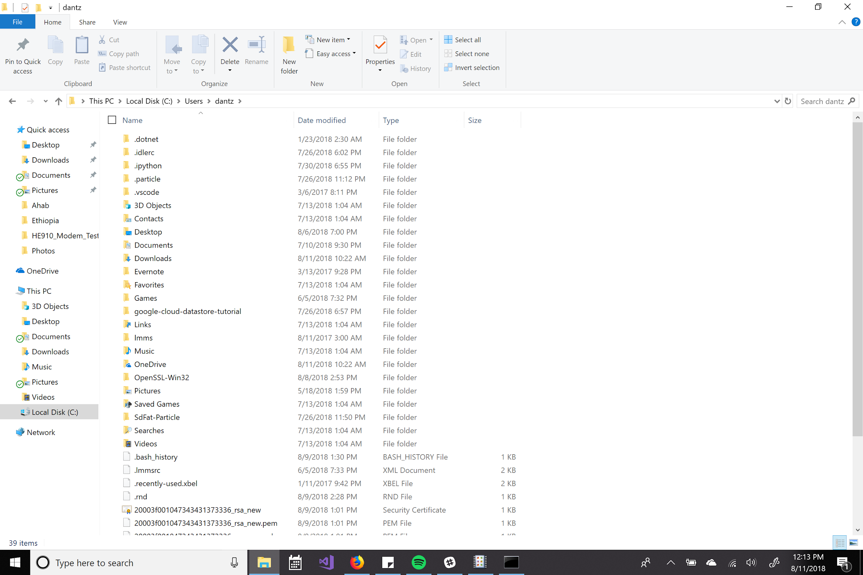
Here you can also see the .particle file library.

Create a particle account by clicking the login button in the upper right hand corner and following the prompts: https://www.particle.io/

Install particle command line interface: https://docs.particle.io/guide/tools-and-features/cli/photon/#using-windows

Photon Setup Walkthrough

Open your command prompt (I’m on Windows)
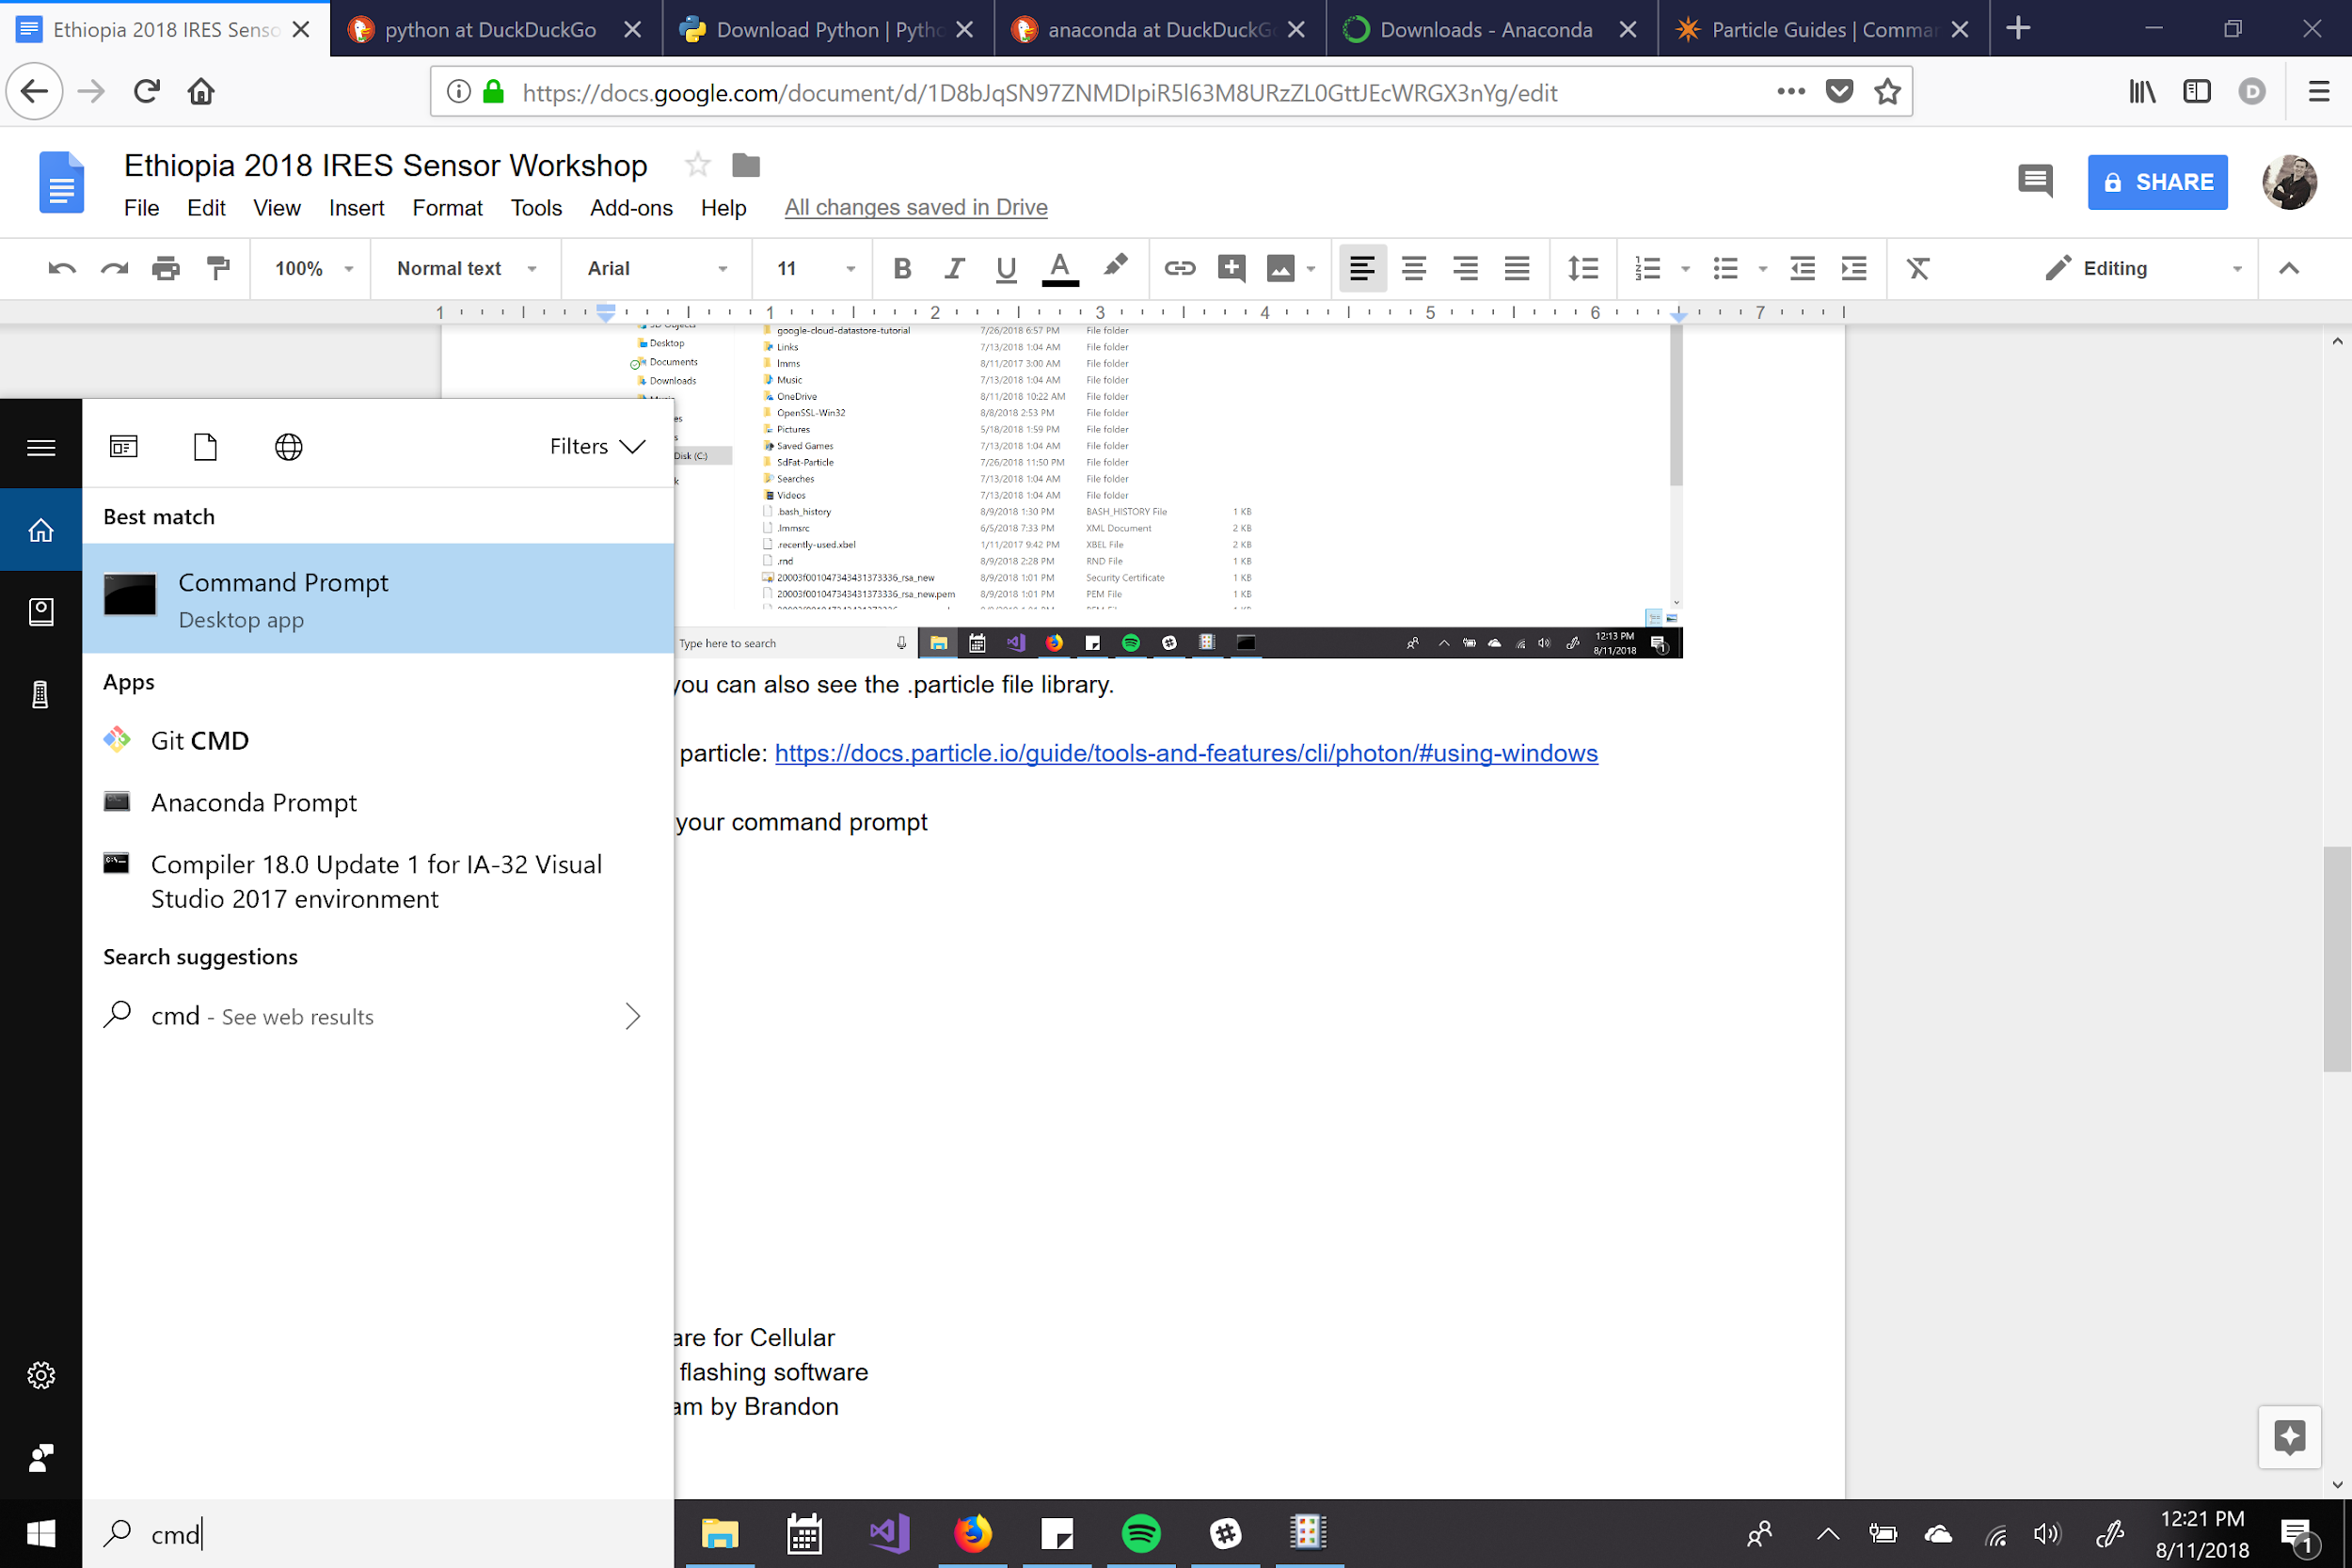

The particle photon has a micro usb port. I’ll go through two methods of setup here: via usb connection (sometimes faster but seems to have more bugs), and via wifi (slower but usually works more straightforward).

Via USB

Firstly plug the USB cable into your computer and photon, then open your command prompt and type in “particle setup”

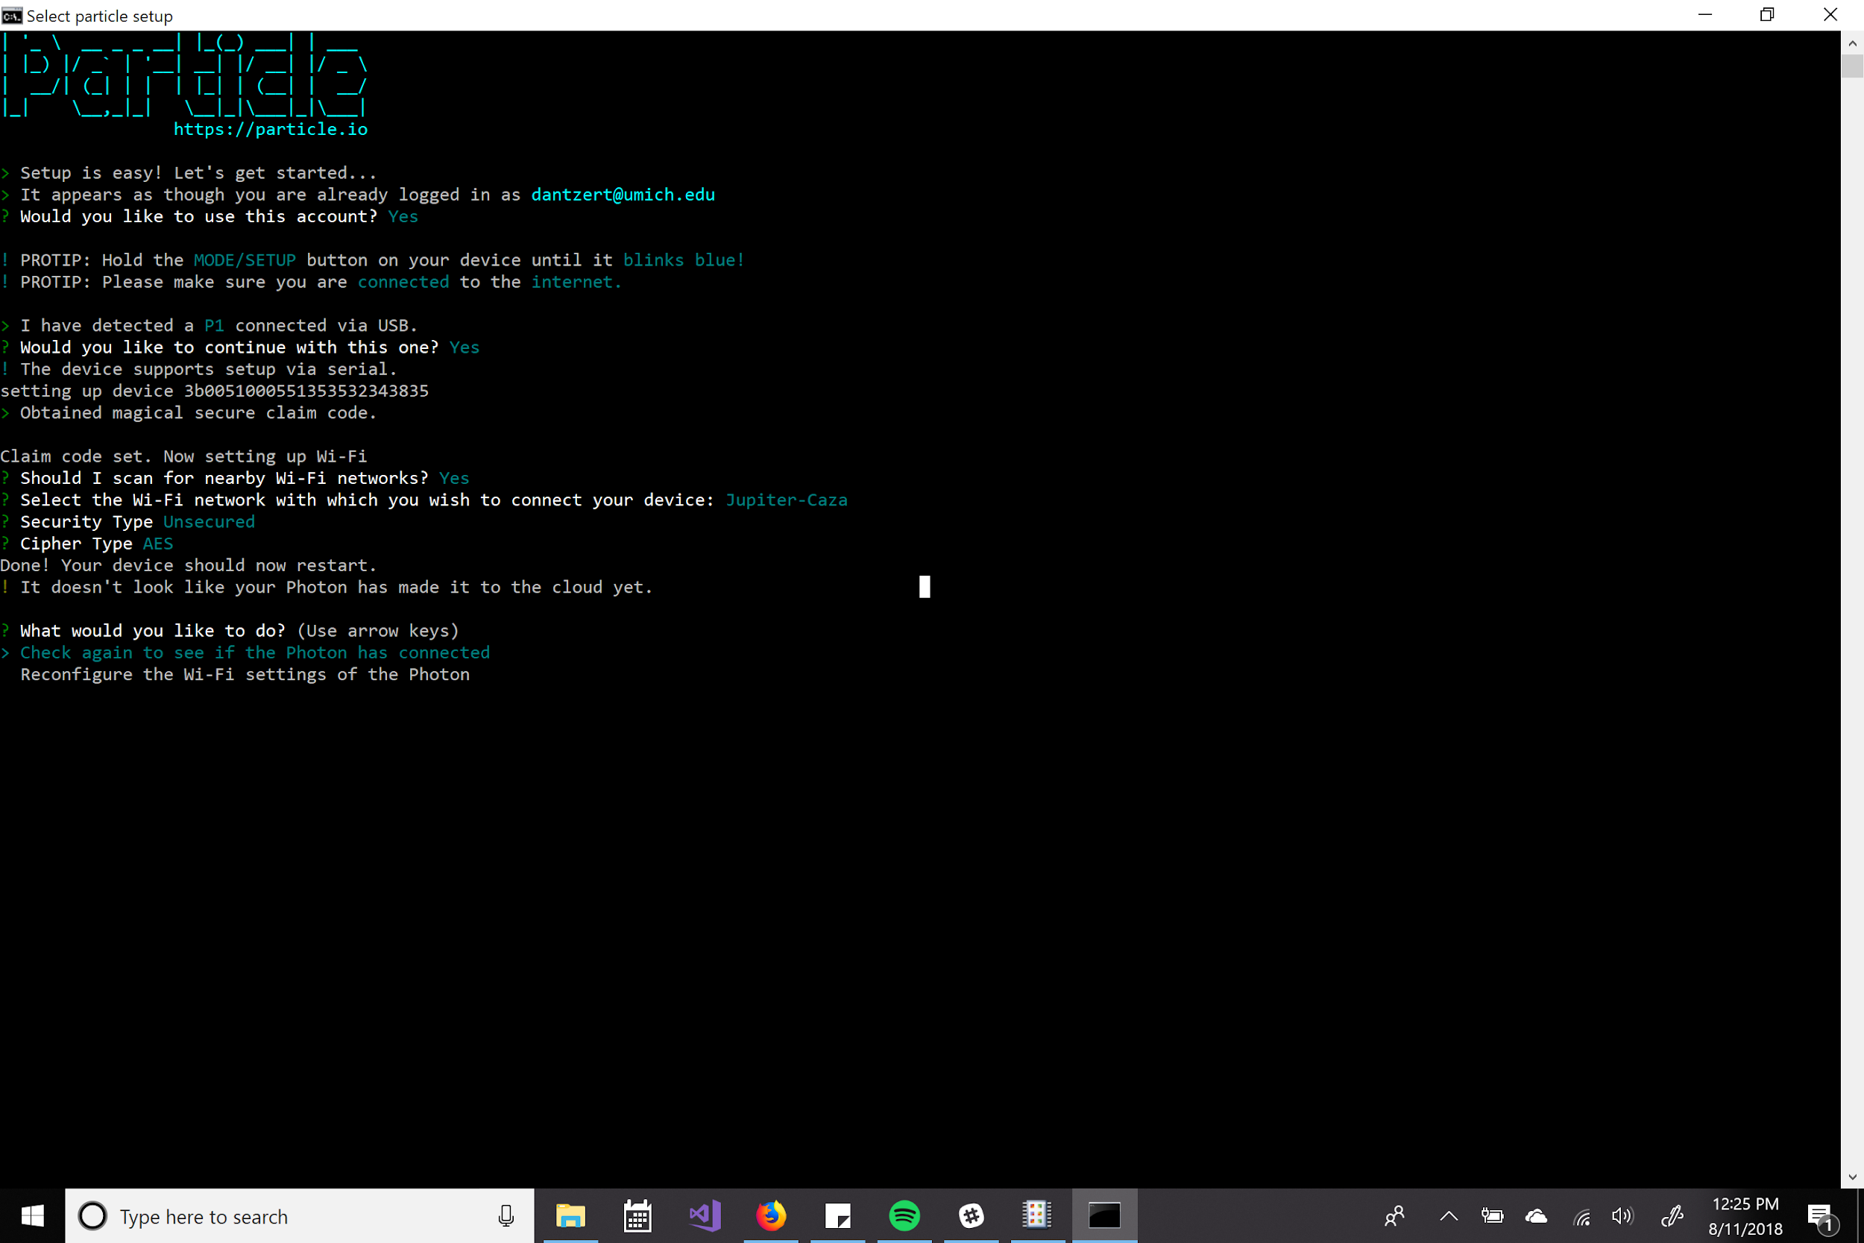
The Photon Board seems to have an issue with open networks as it will ask for cipher type. In my experience if the board asks for cipher type, it’s not going to work. Try connecting to the board a different way (via wifi) or running “particle device doctor” and trying again.

On a secured wifi network the setup will ask you for the password (but not the cipher type) and work as expected.

I have never been able to successfully connect to a network when the particle menu asked for the cipher type. What’s worked for me in that case has been setup via Wifi (not USB).

Setup via Wifi

Plug the Photon Board into a power supply via the USB (or a battery pack) and put it into listening mode (blinking blue).

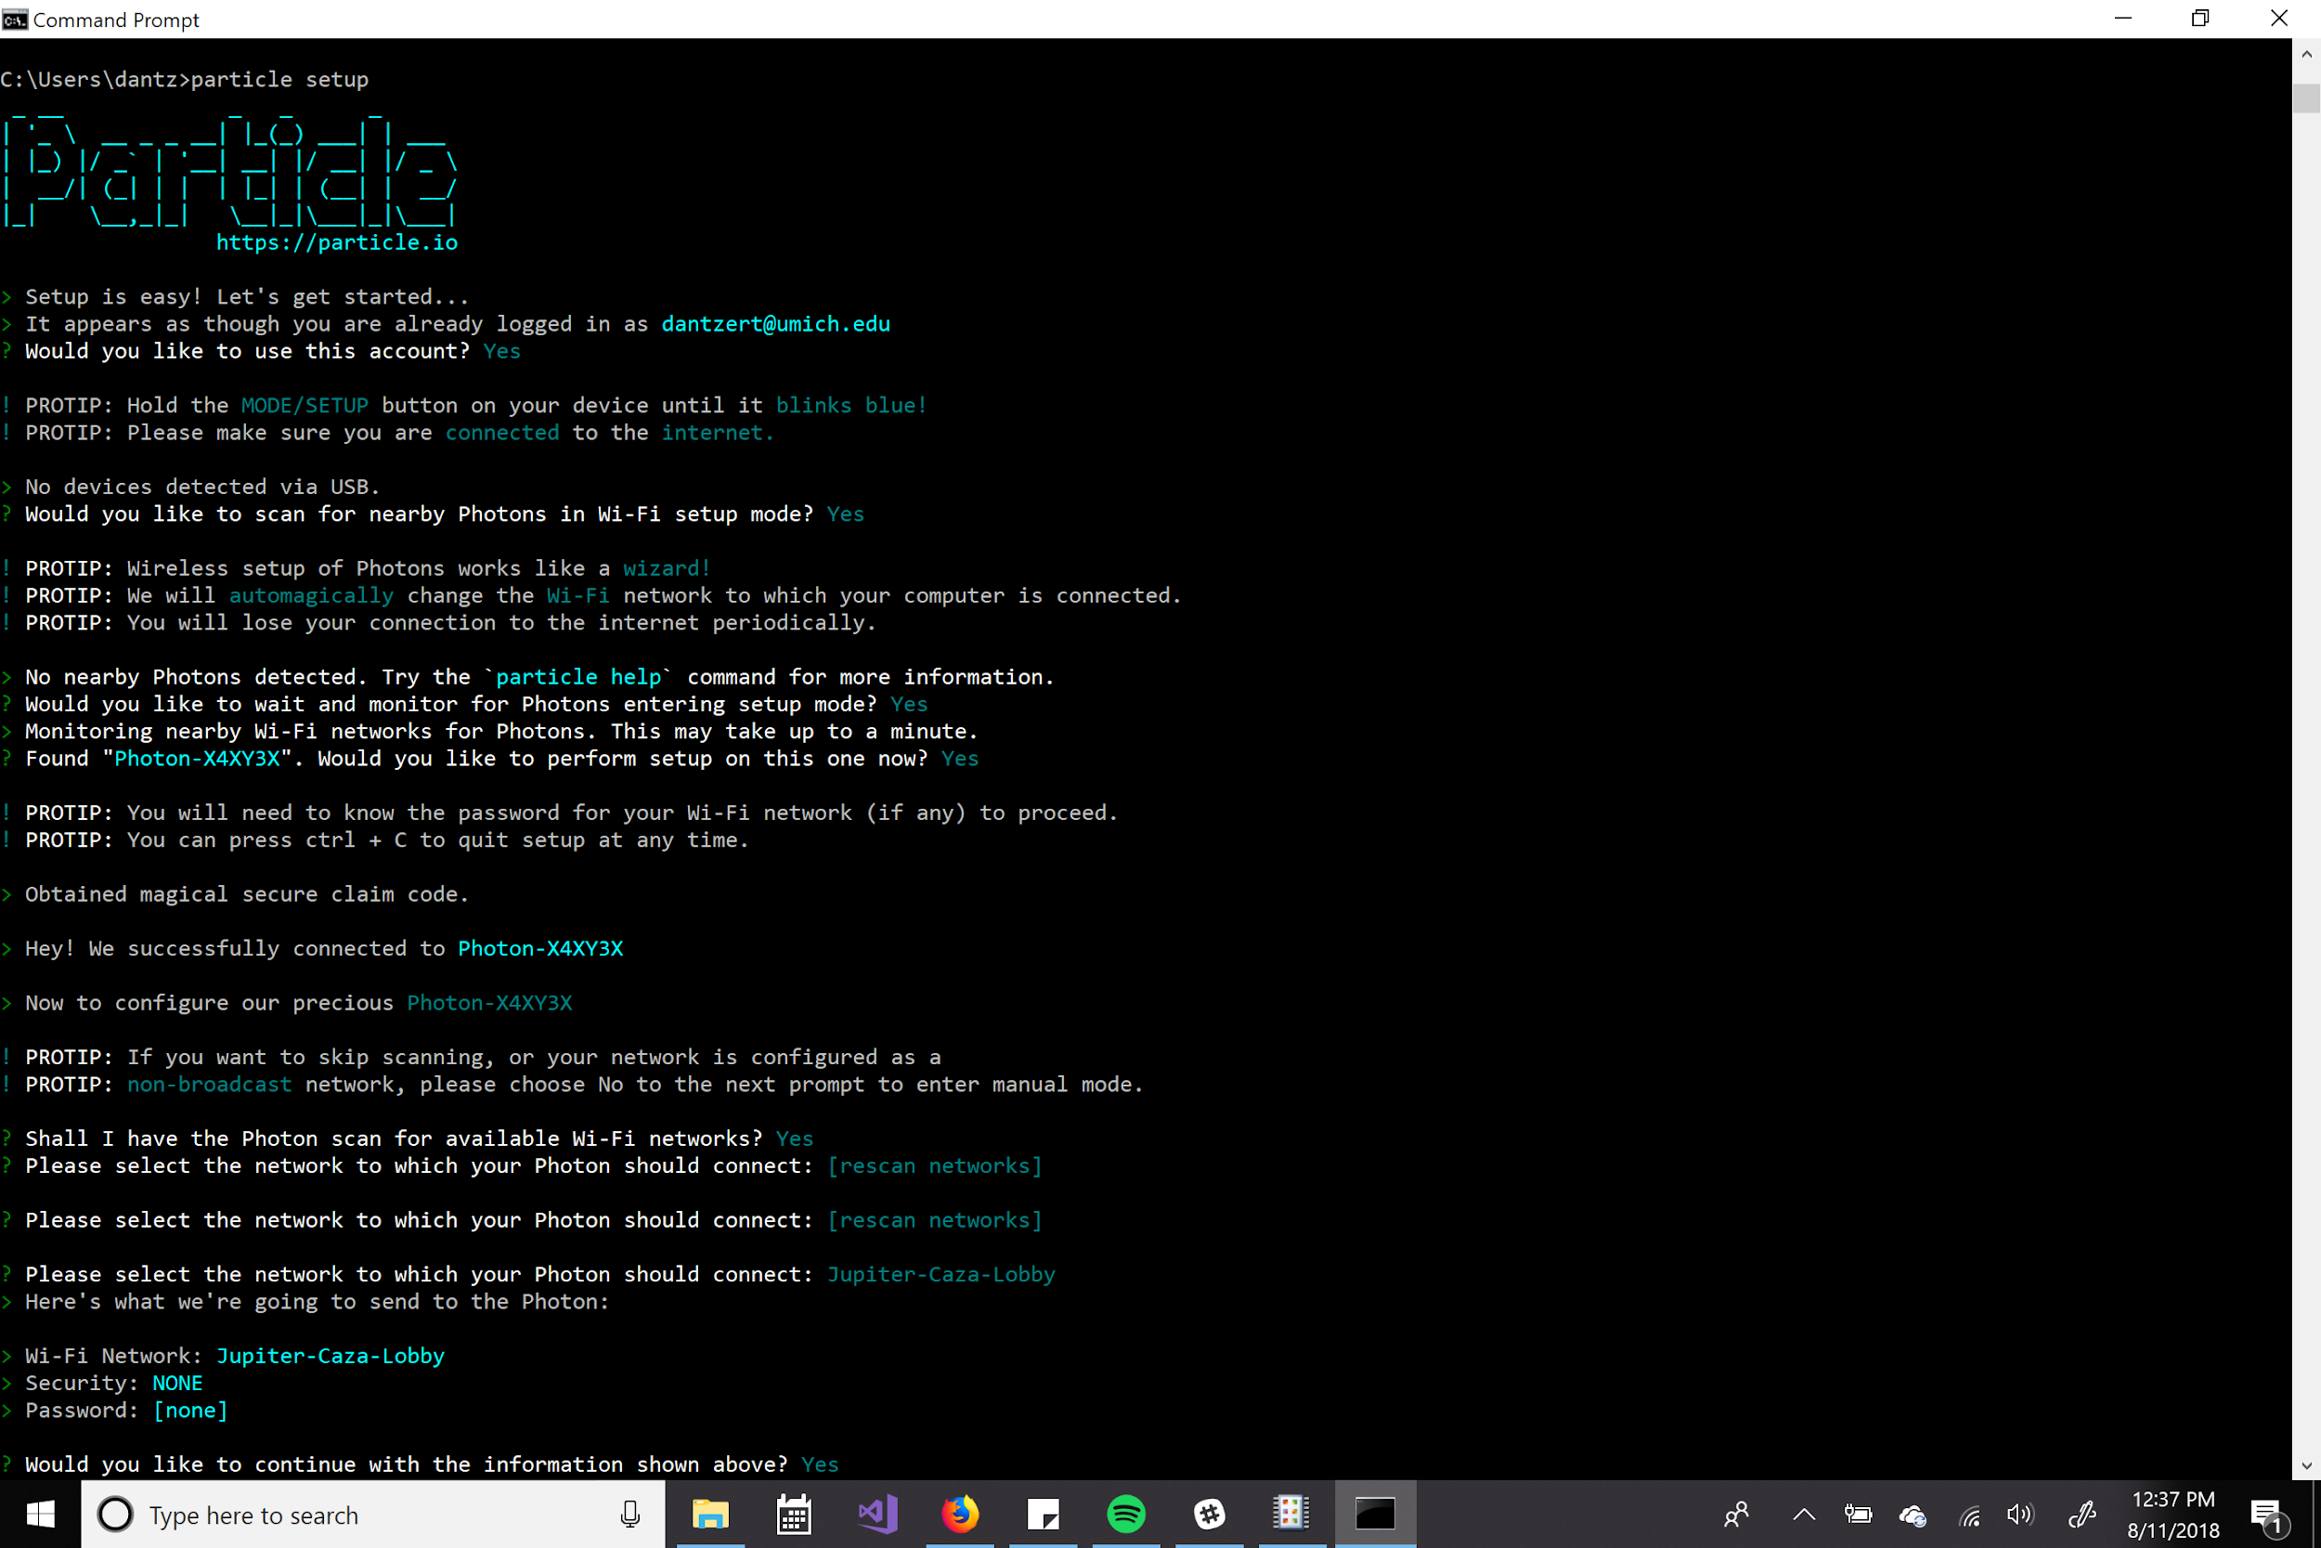

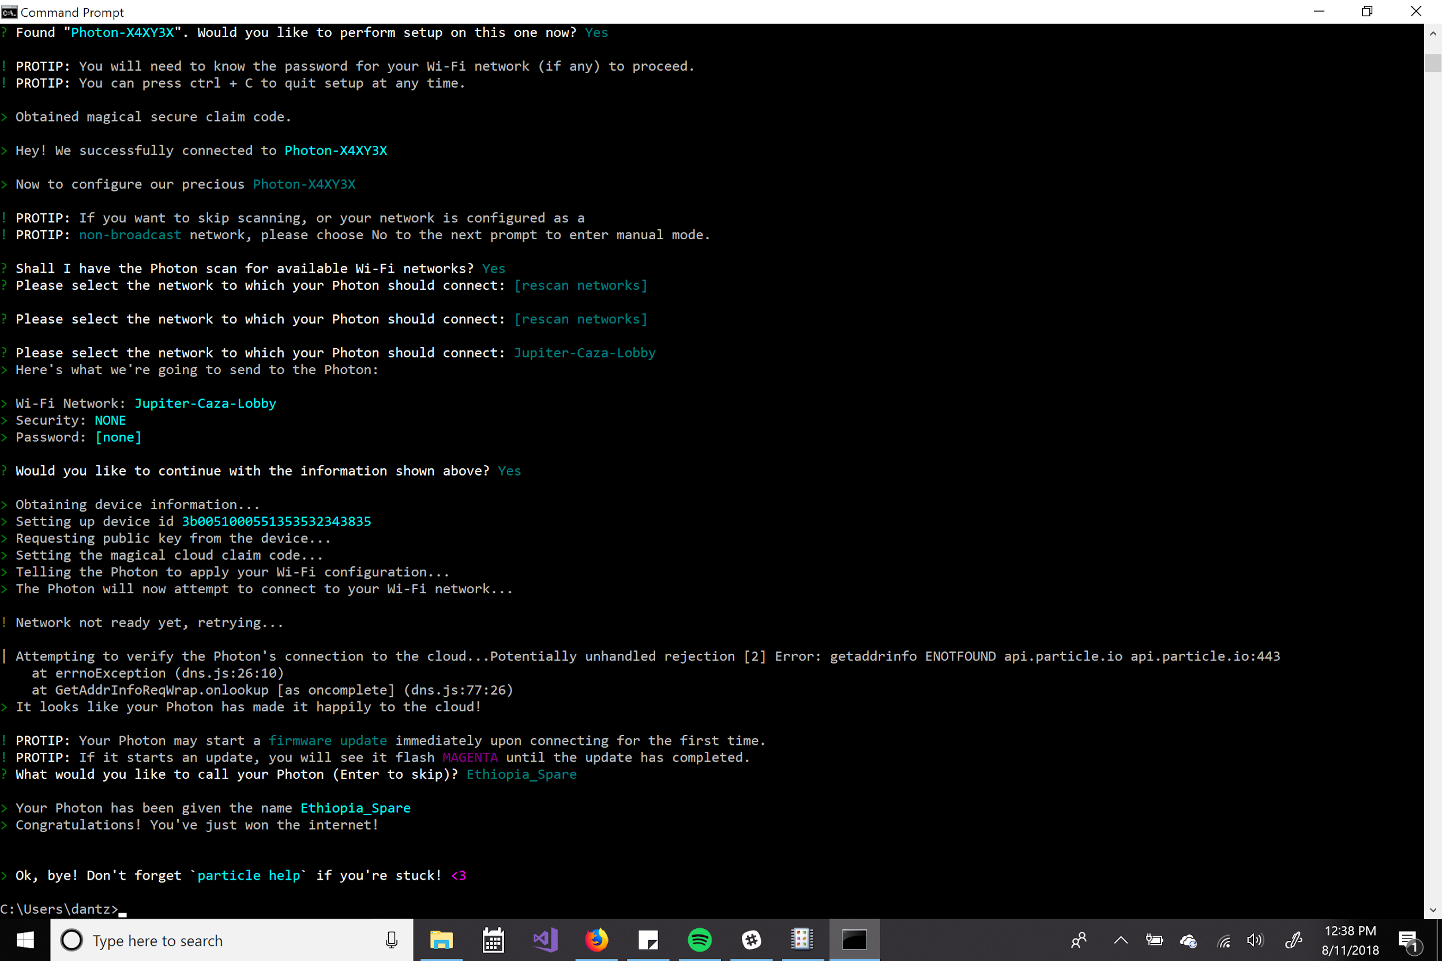

Setup via Wifi seems to be less buggy and work more as expected (as you have to go through the Wifi network in the first place and are never relying on a physical connection) but it often takes longer.

Basically, the photon begins broadcasting as though it were a modem when it’s in listening mode, so you must make sure that your computer can pick up the photon’s signal.
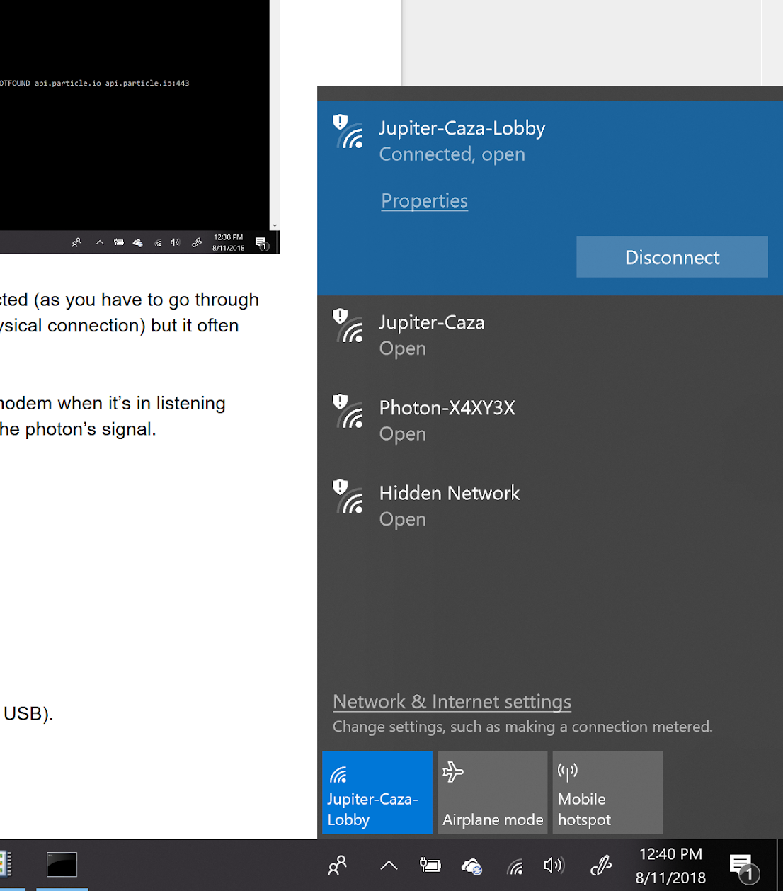
Here, it’s Photon-X4XY3X

Particle Device Doctor
The device must be plugged in to the computer (as in setup via USB).
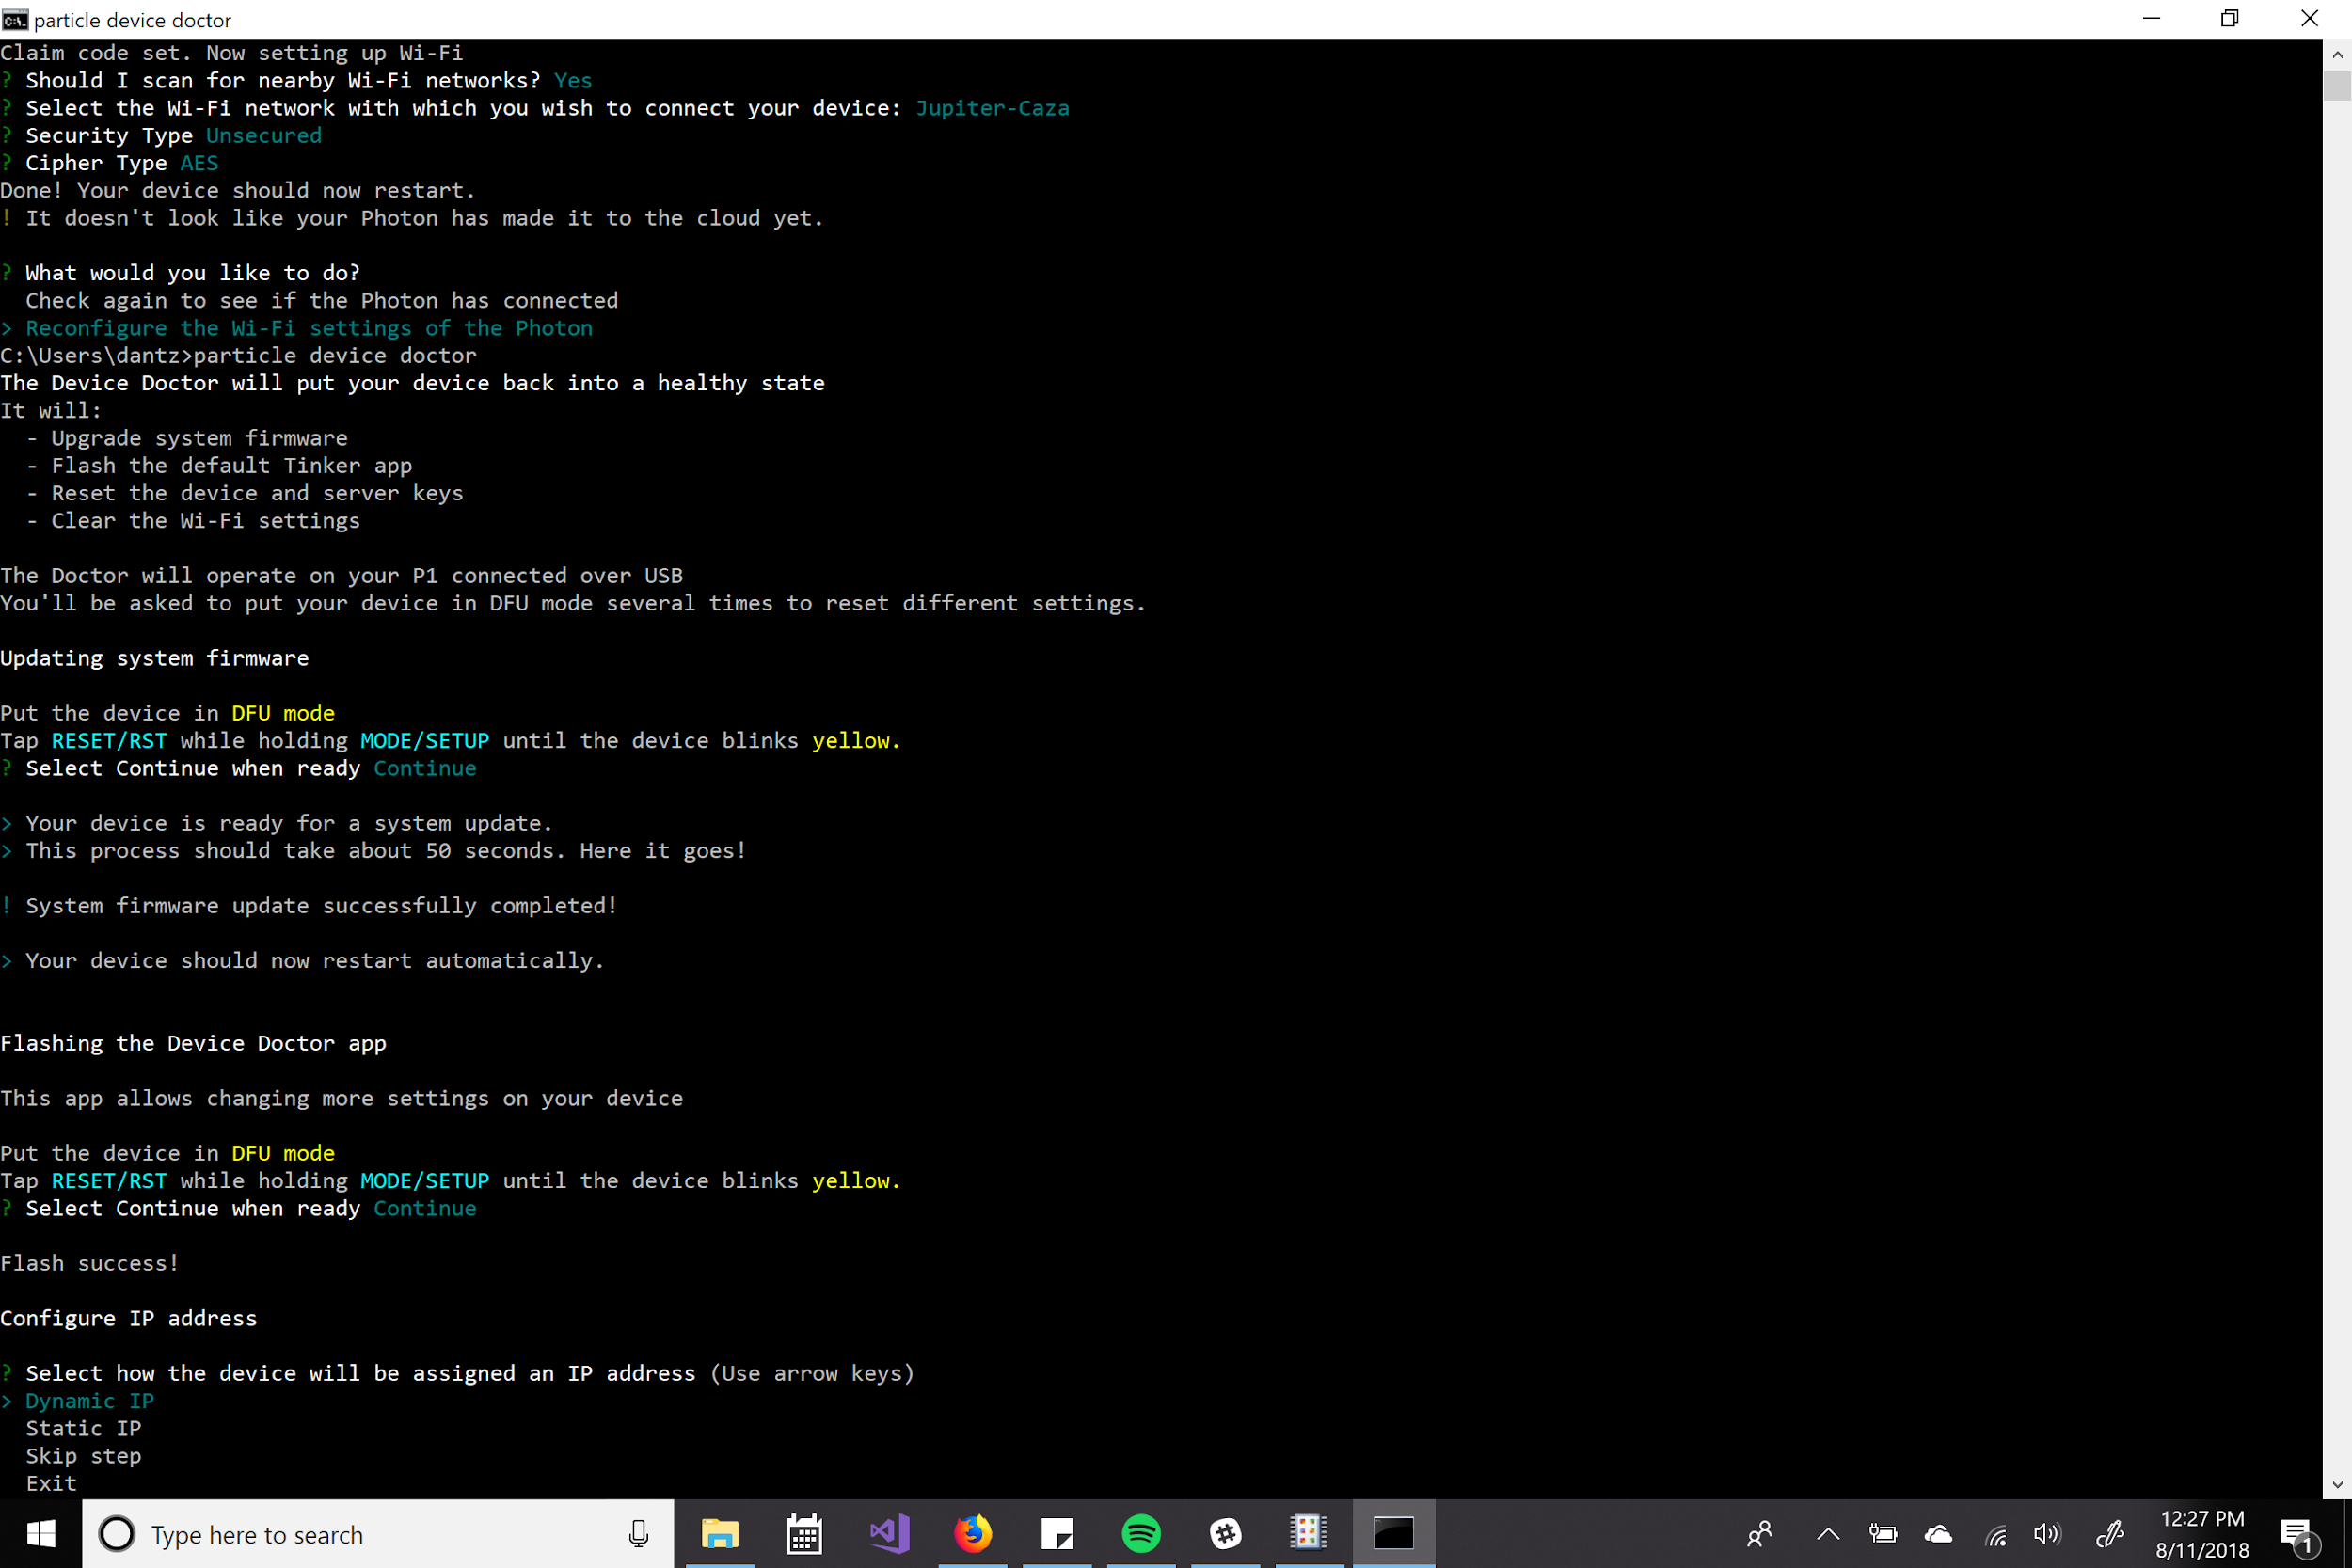
If you’re having difficulty with the network (you’ve tried two or three times and it keeps asking you for the cipher type) try skipping the wifi setting setup in particle device doctor.
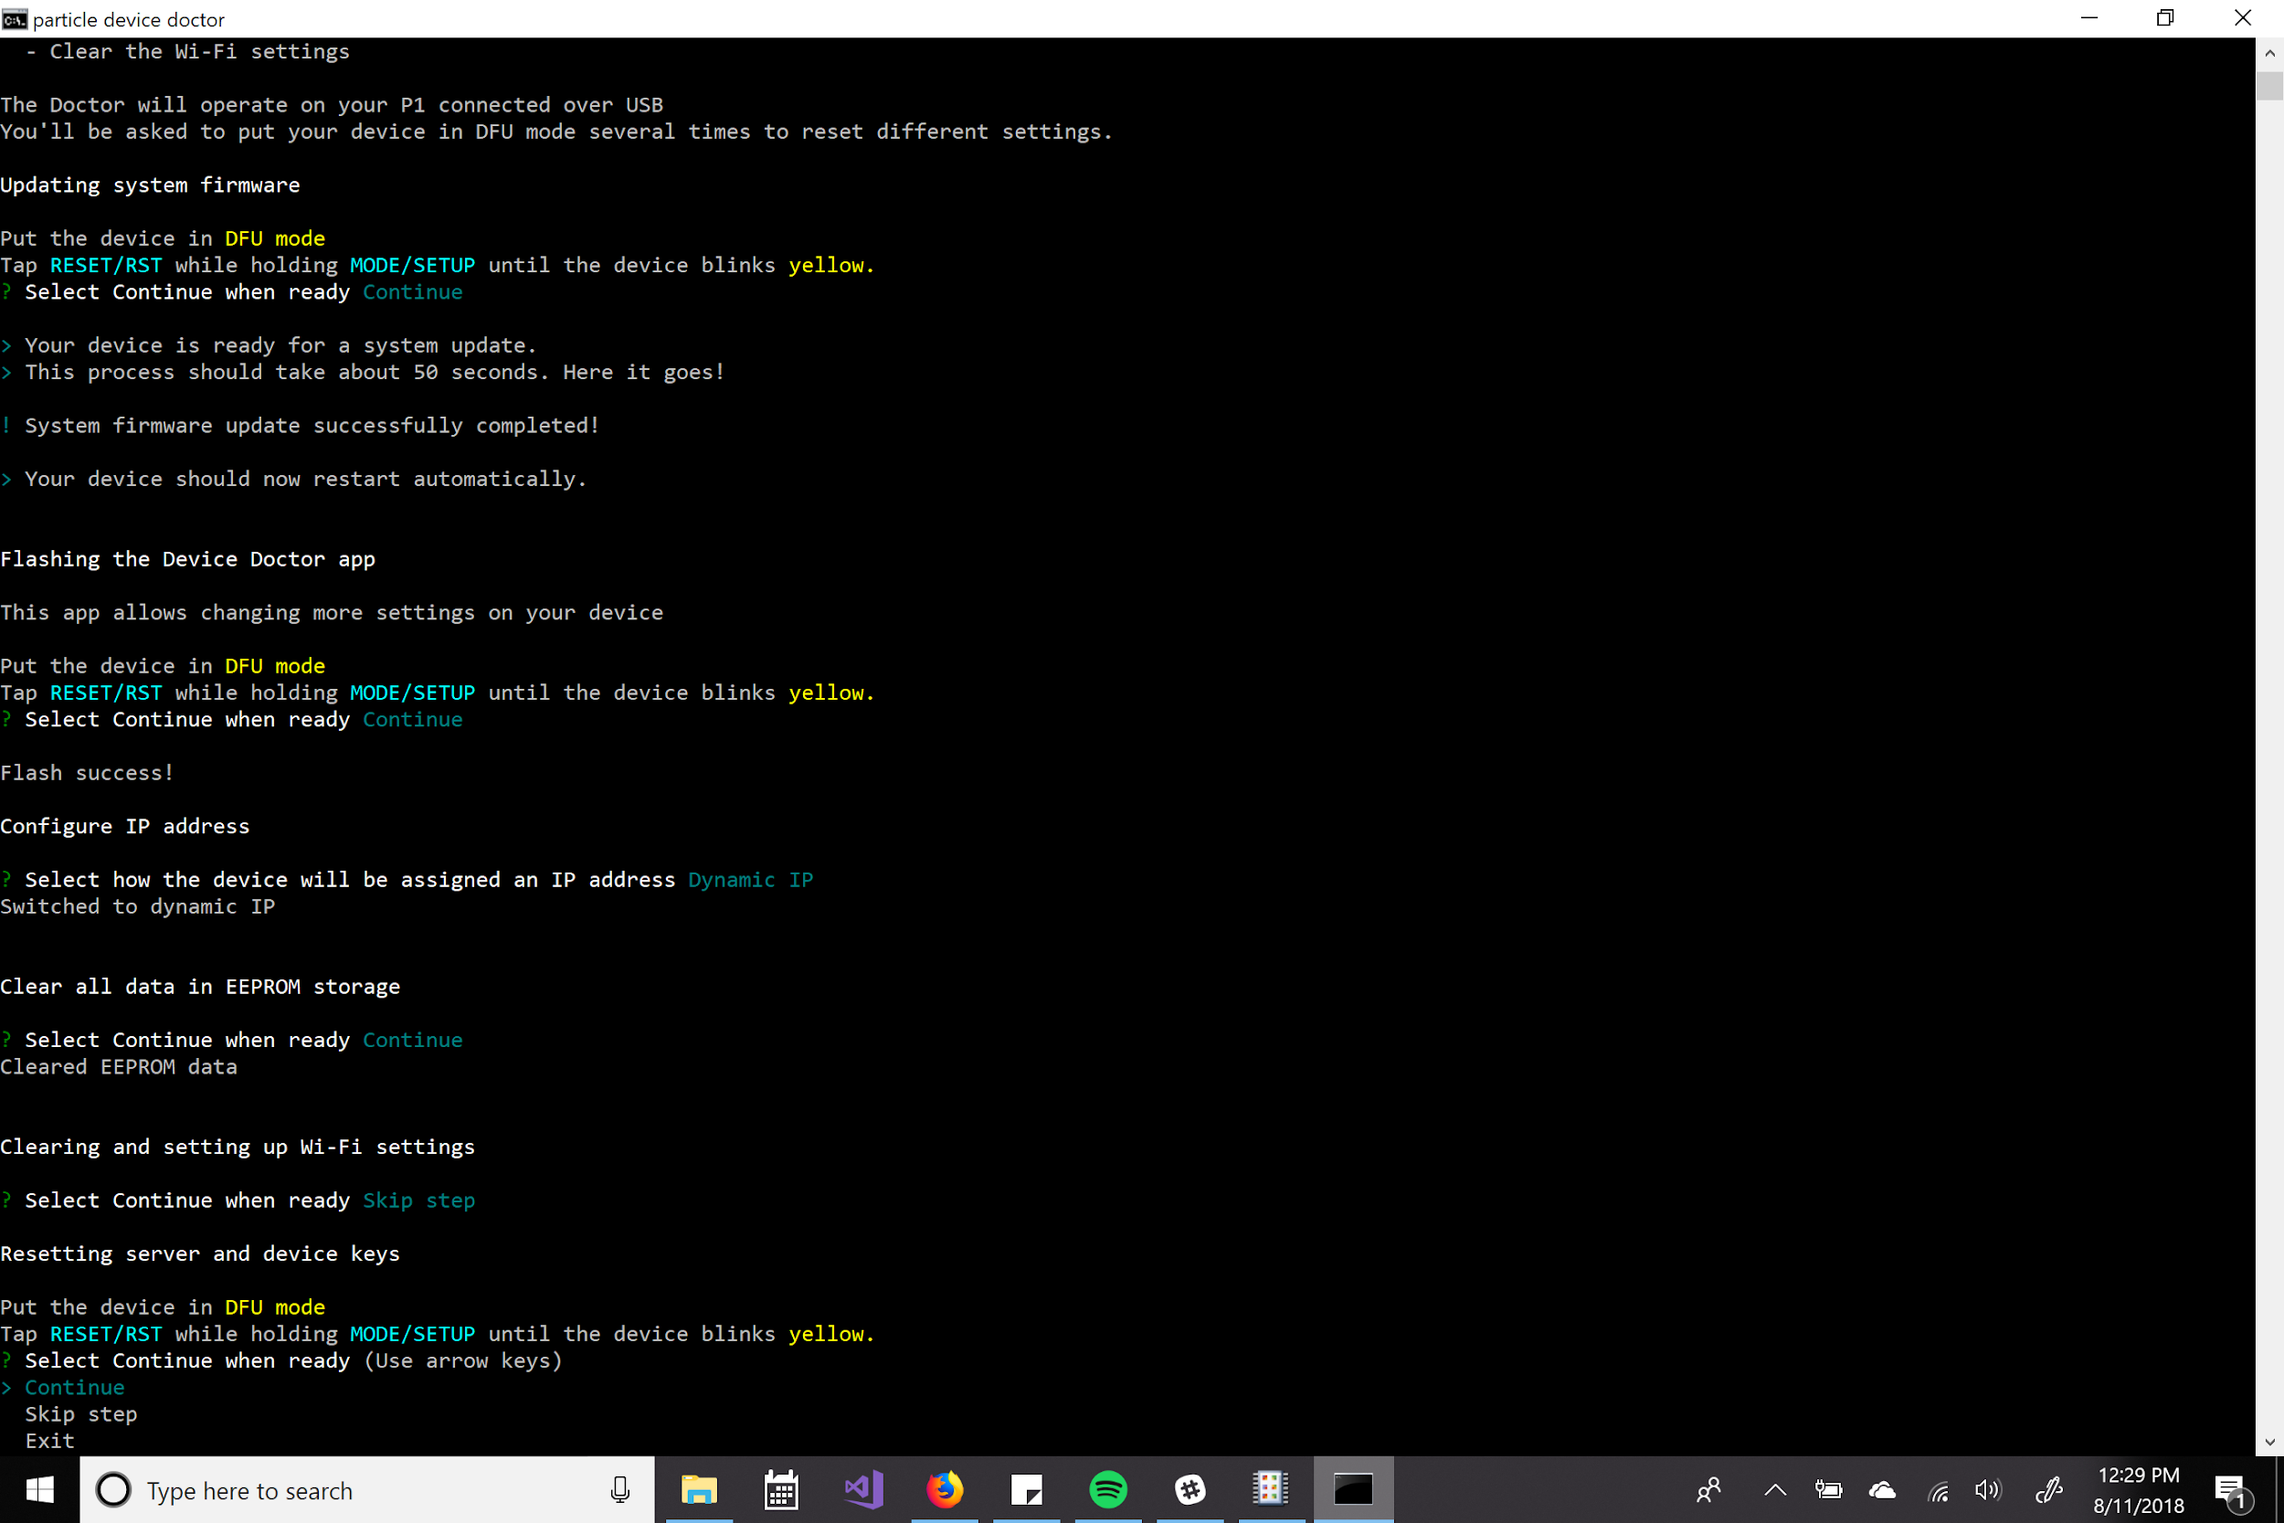
If you’re getting an error on key creation, that’s likely a path issue with openssl.
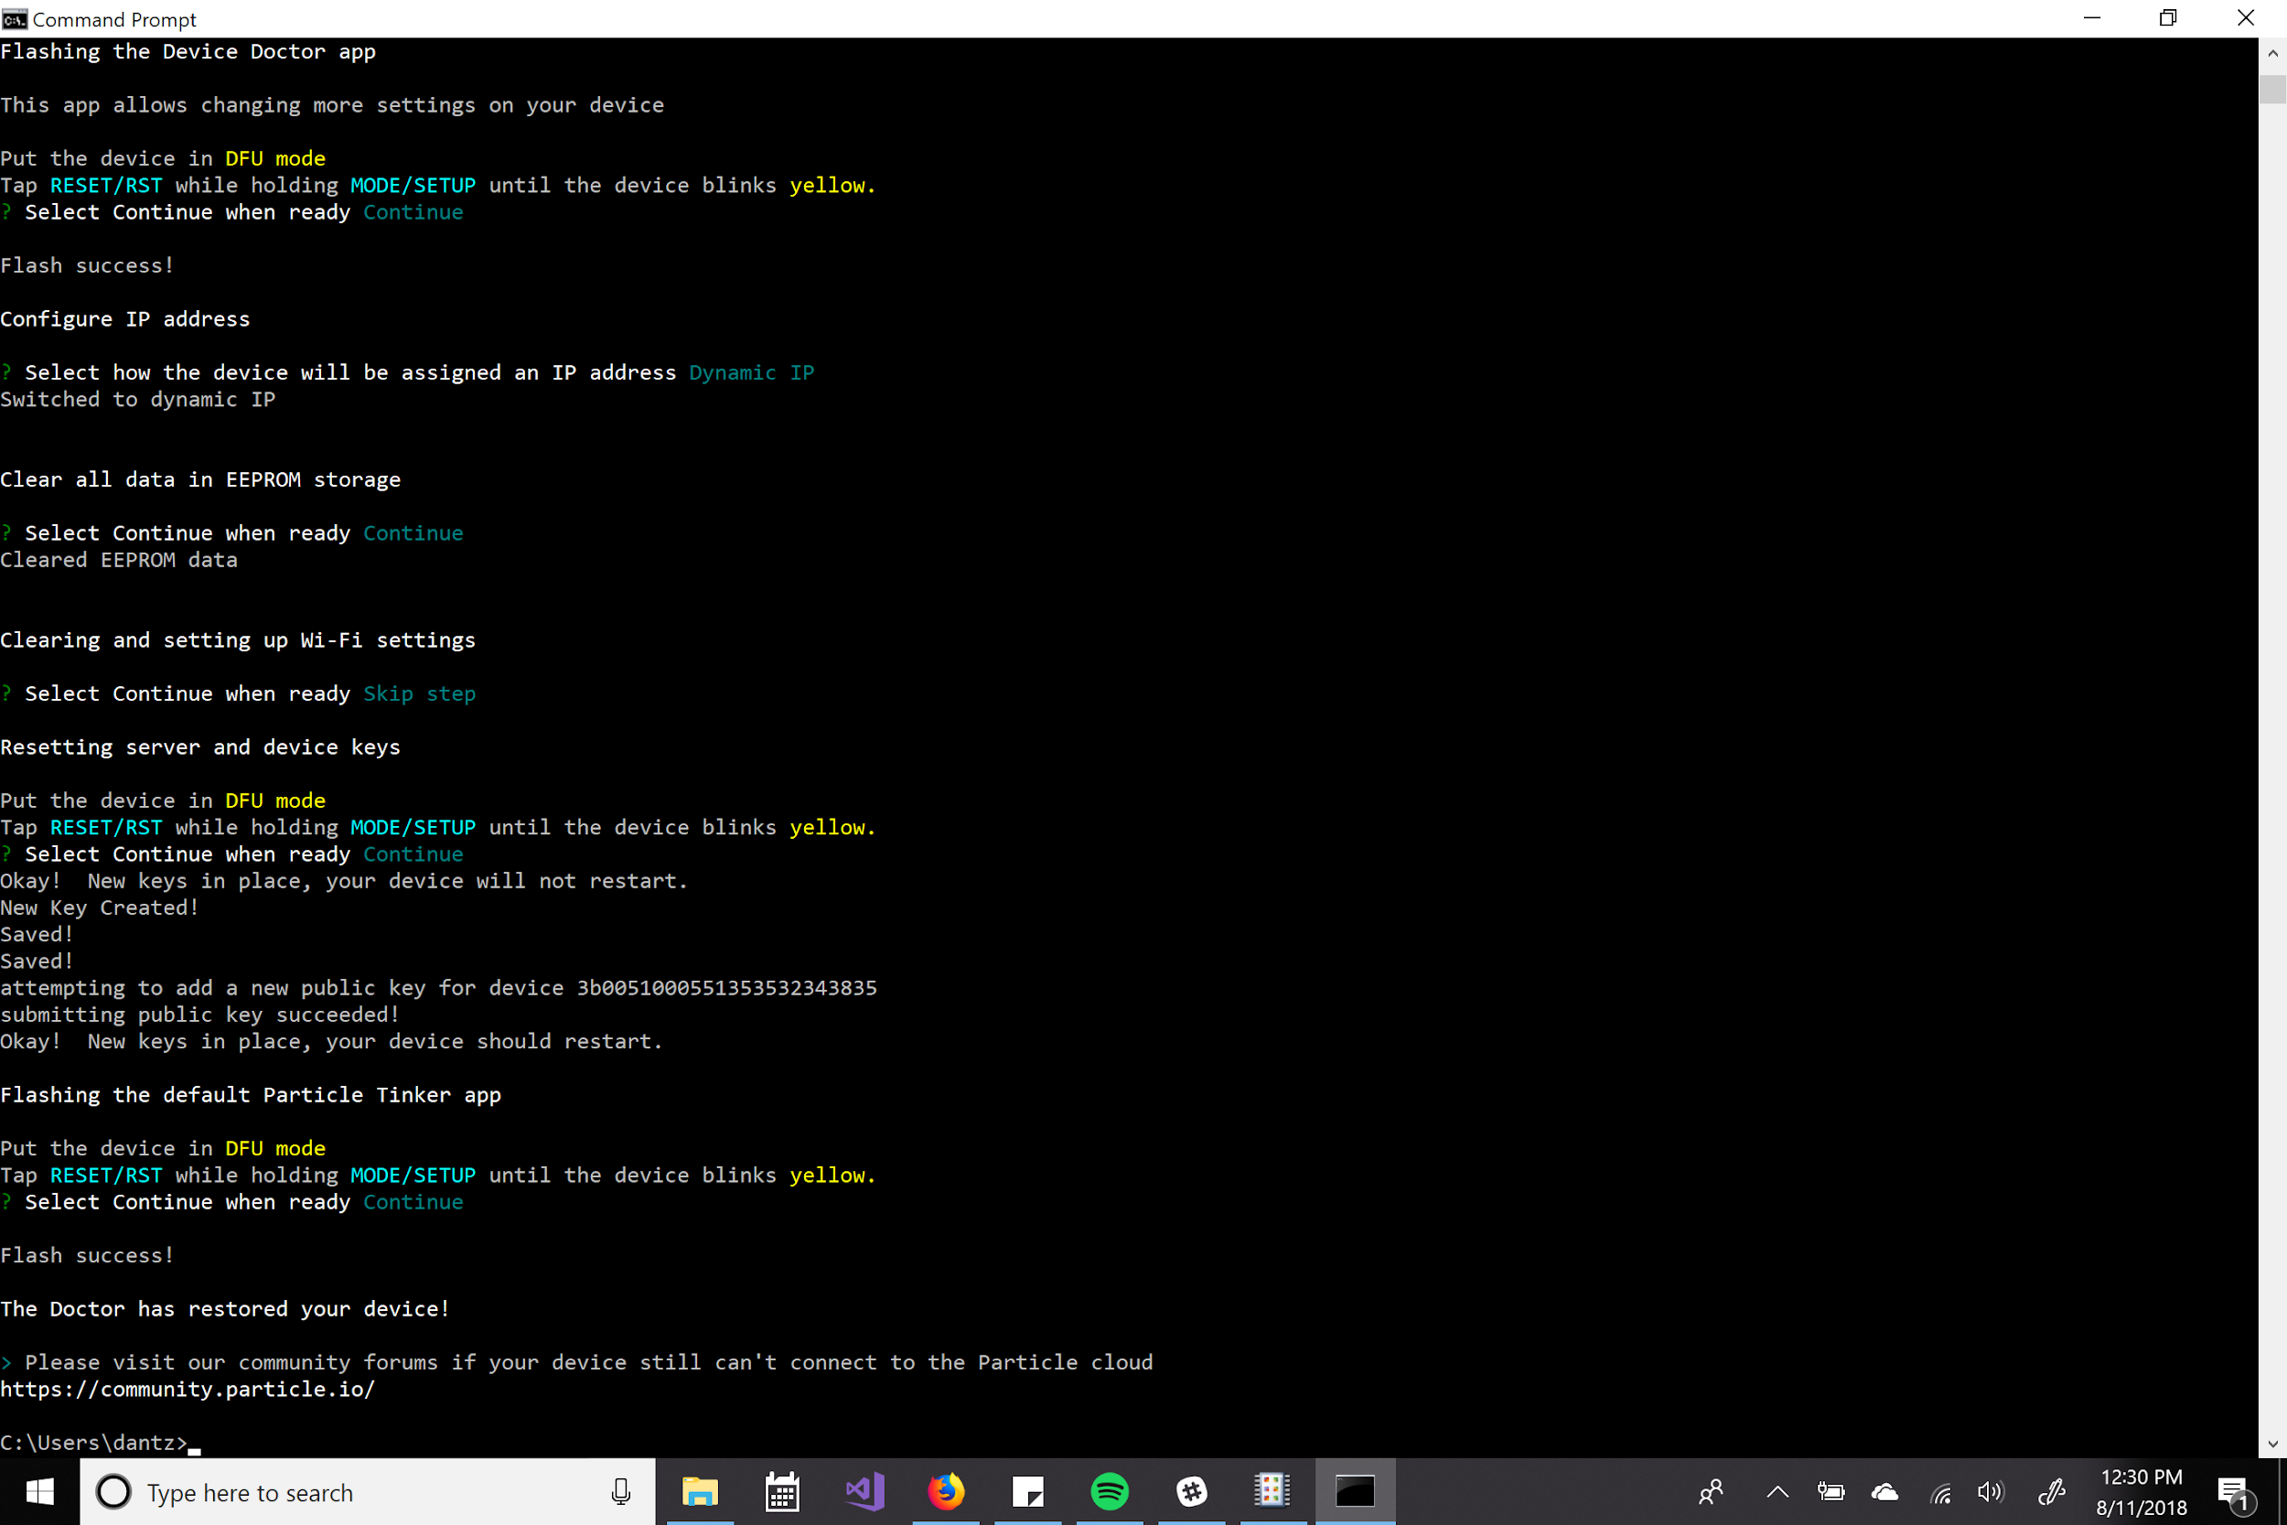

Transferring Ownership of Devices

On the particle cloud devices are registered to an account. Once you run through setup on a device it will be registered as your device and you’ll be able to flash firmware to the device.

Creating an Account

https://login.particle.io/login

https://login.particle.io/signup

Utilizing Particle Build (http://build.particle.io/) and Console (http://console.particle.io/)

I’ll show a simple function that will just post a random analog reading (whatever the terminal is floating at as there’s no sensor attached) as a way to show how to use Build and Console.

Use the “Device” Tab to select the appropriate Photon
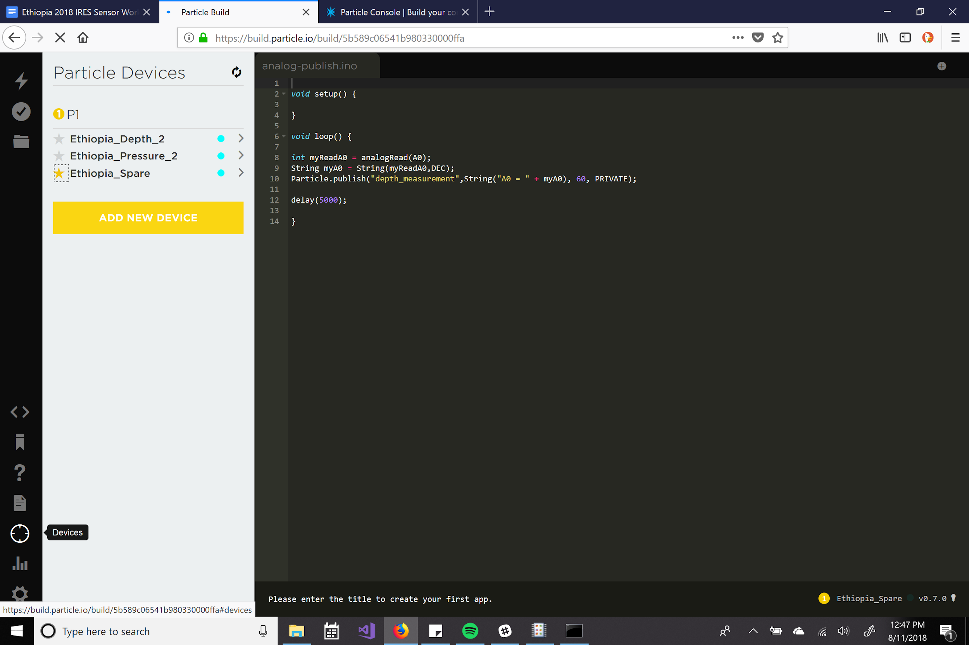
And select the code you desire to flash to that photon
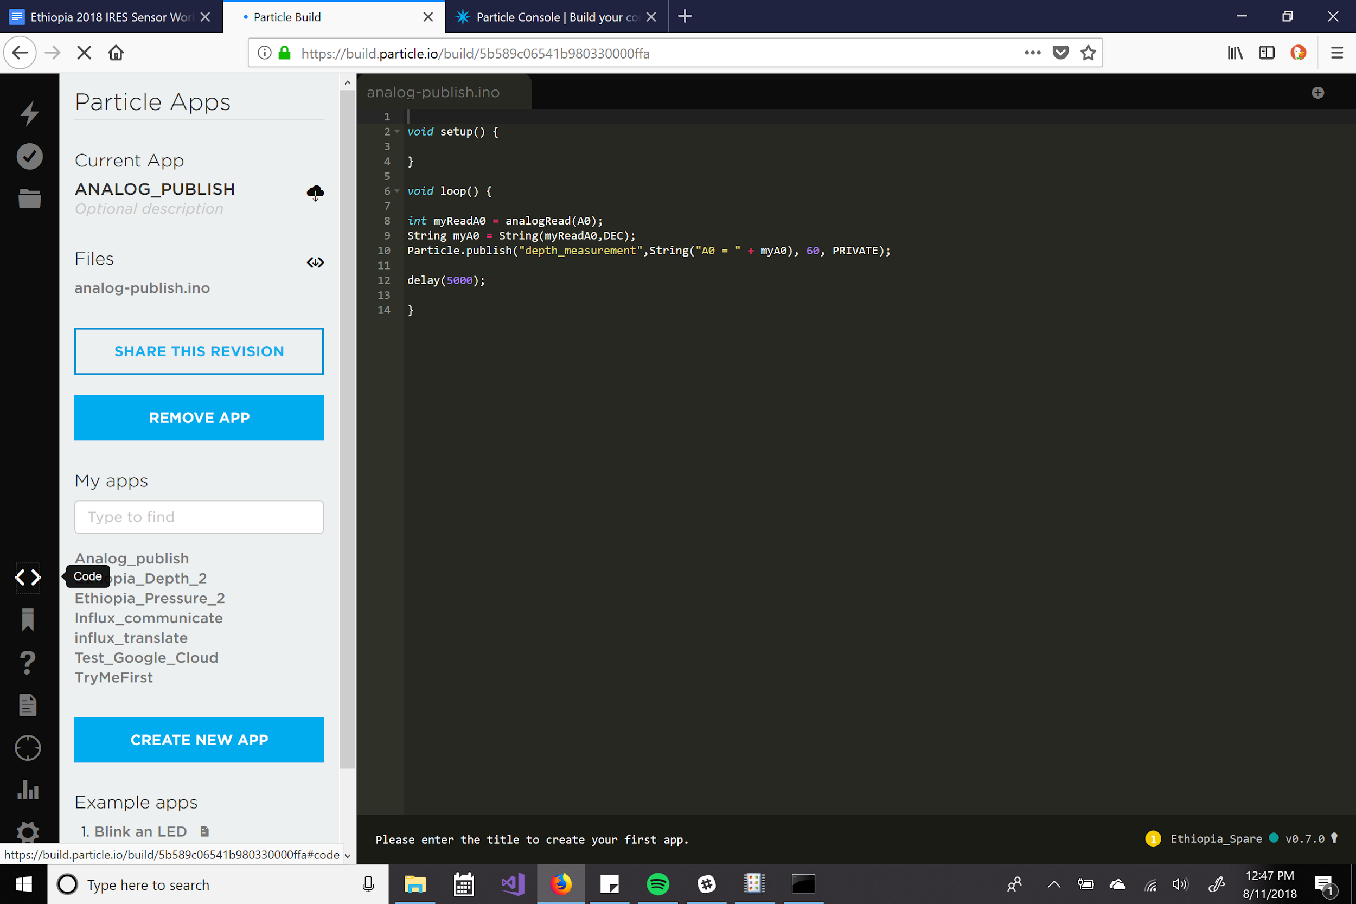
What you should see after you click the flash icon in the upper left corner.
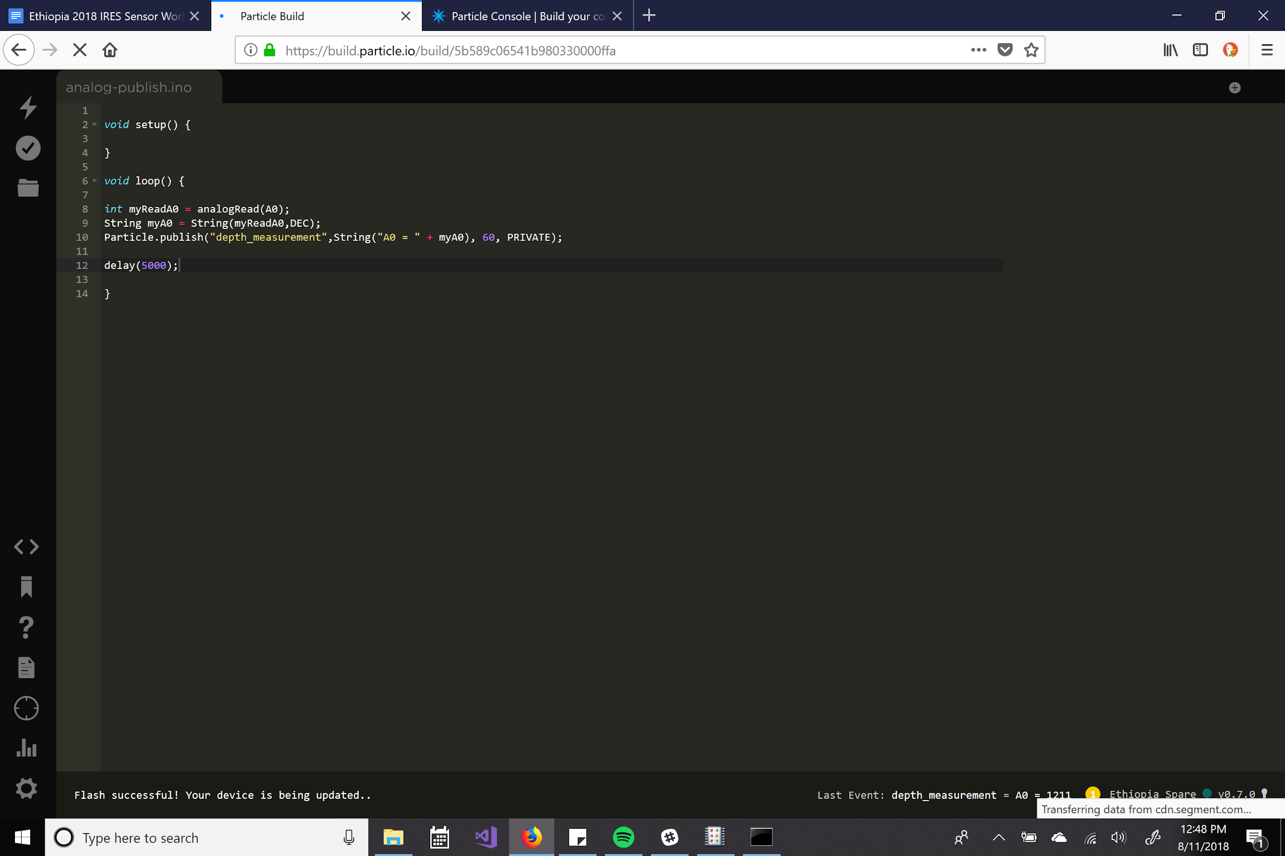
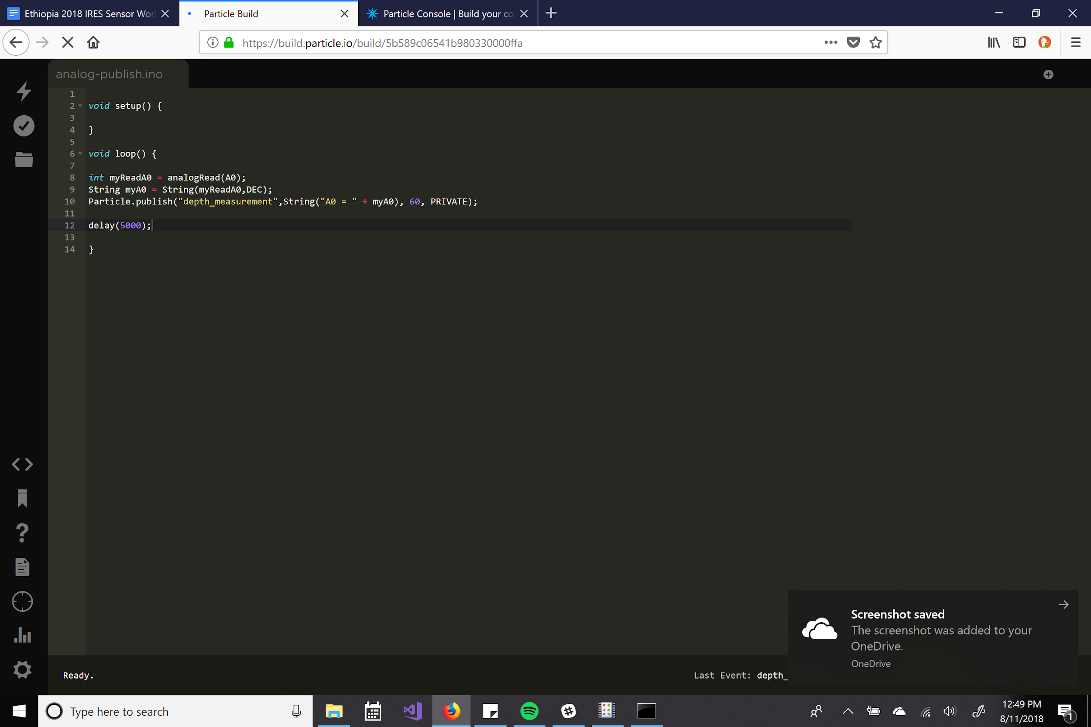
Going to the “Events” tab of Particle Console should show our meaningless readings.

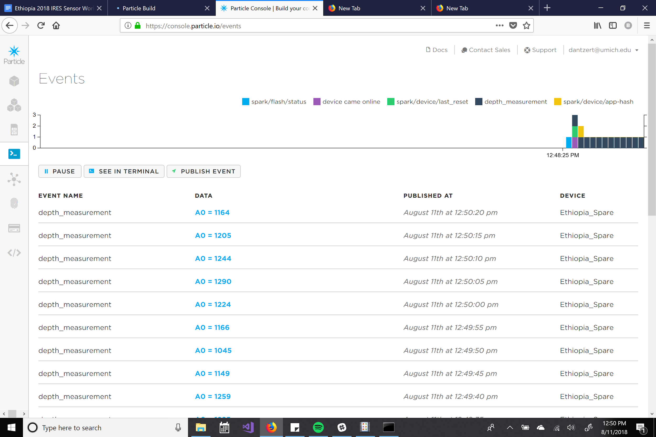

Turning the delay small (such as five seconds) and consulting Console is a good way to check and make sure your sensors are working correctly.

Currently Used Firmware

Depth: https://go.particle.io/shared_apps/5b6d9f1b85d3ae9e420004b6

Pressure: https://go.particle.io/shared_apps/5b6d639985d3aeba8e0002ed
Pressure needs to be altered as it currently outputs the raw analog voltage reading.

Viewing the Grafana stream

http://data.open-storm.org:3000/?orgId=8

Sign in information for data stream

UserName: ADD
Password: stream_sensors
Currently no stream as all the batteries are dead.

Cellular Board Required Software

PSoC

Download PSoC Creator 4.1 : http://www.cypress.com/documentation/software-and-drivers/psoc-creator-software-archive

PSoC Programs

If you’re failing on “arm-...” commands make sure emFile_V322c folder is in the same folder as your project folder. Download the whole folder for the next steps.

Debugging PSoC Program : https://drive.google.com/open?id=1V3LbmJkg2S05F0Vo2ngTTq2Yb60-tHCZ

Write to SD and Connect to Cellular : https://drive.google.com/open?id=1hYygl7RHsLSAcjy_CbSAGy7-Th-nmris

Hardware

You’ll just need the PSoc flasher
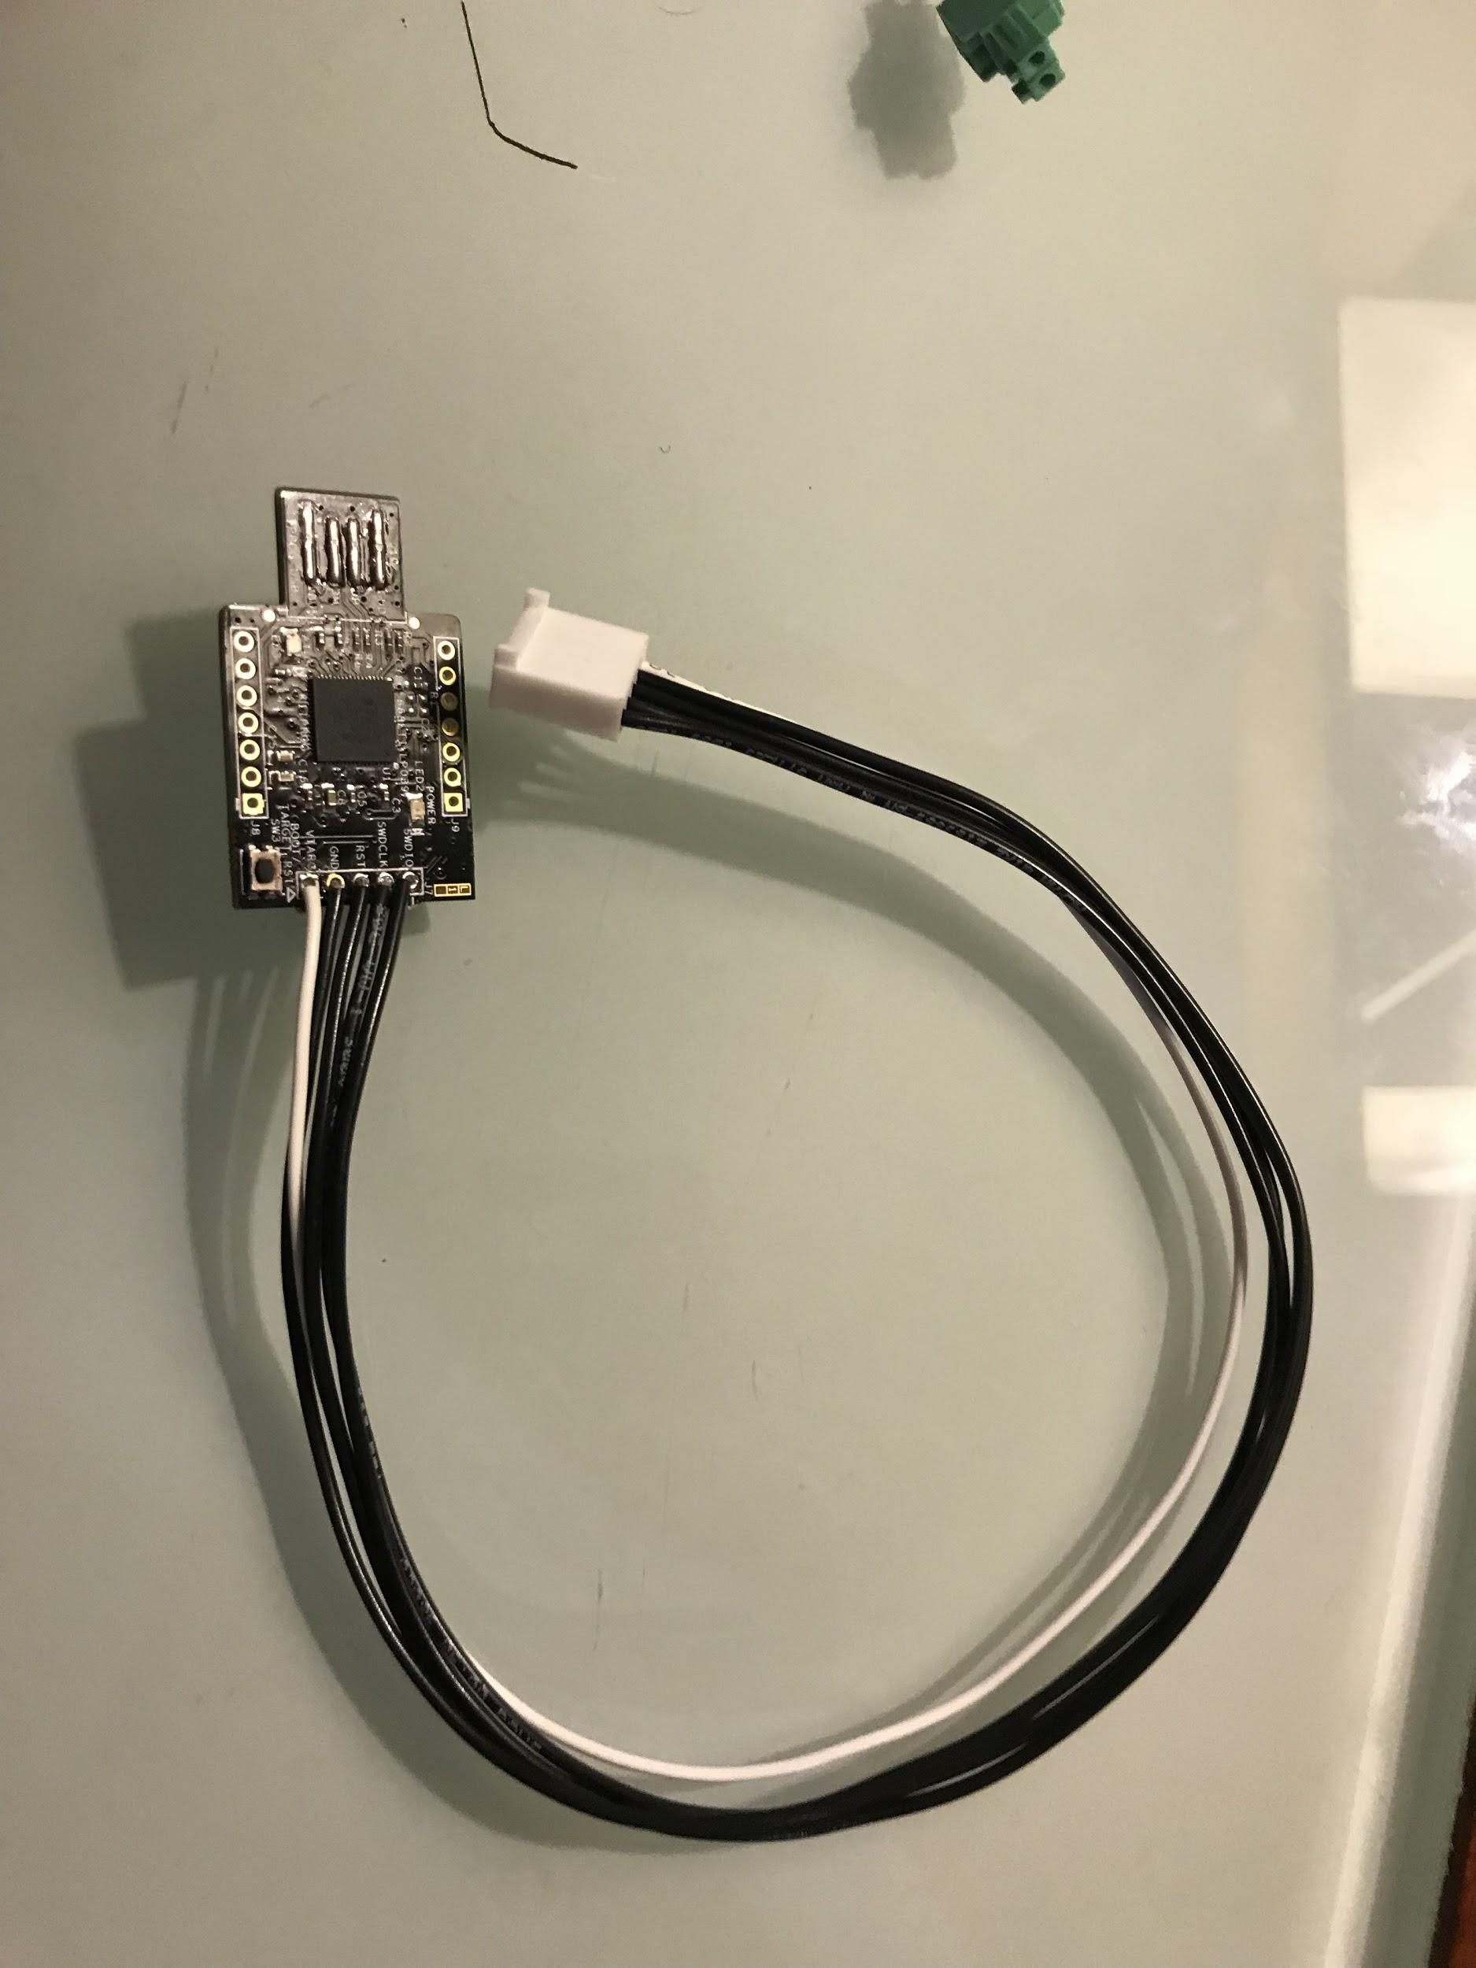
And the green board (shown here assembled)
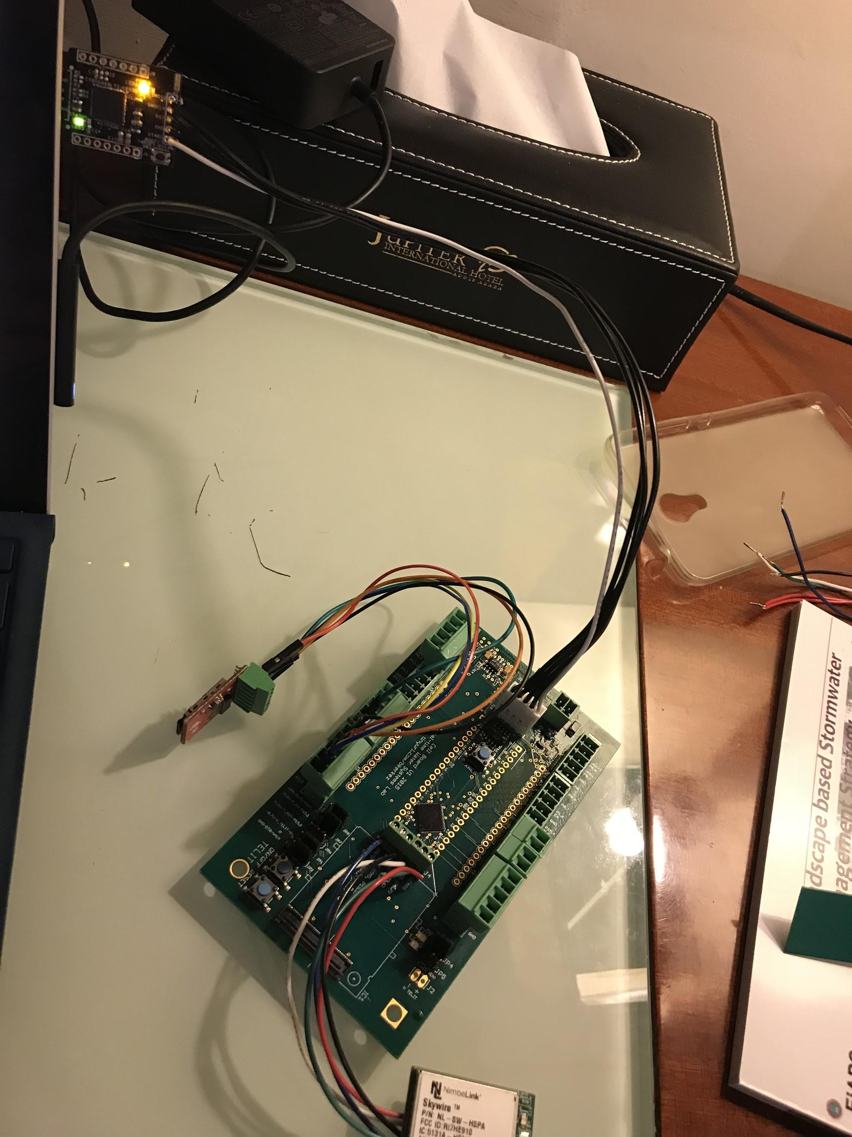
For actually running the firmware you’ll need a power supply other than the debug port (battery here)
Note: Power supply to the modem (red and black wires) has been altered as we were having power problems when routing modem power through the circuit board.
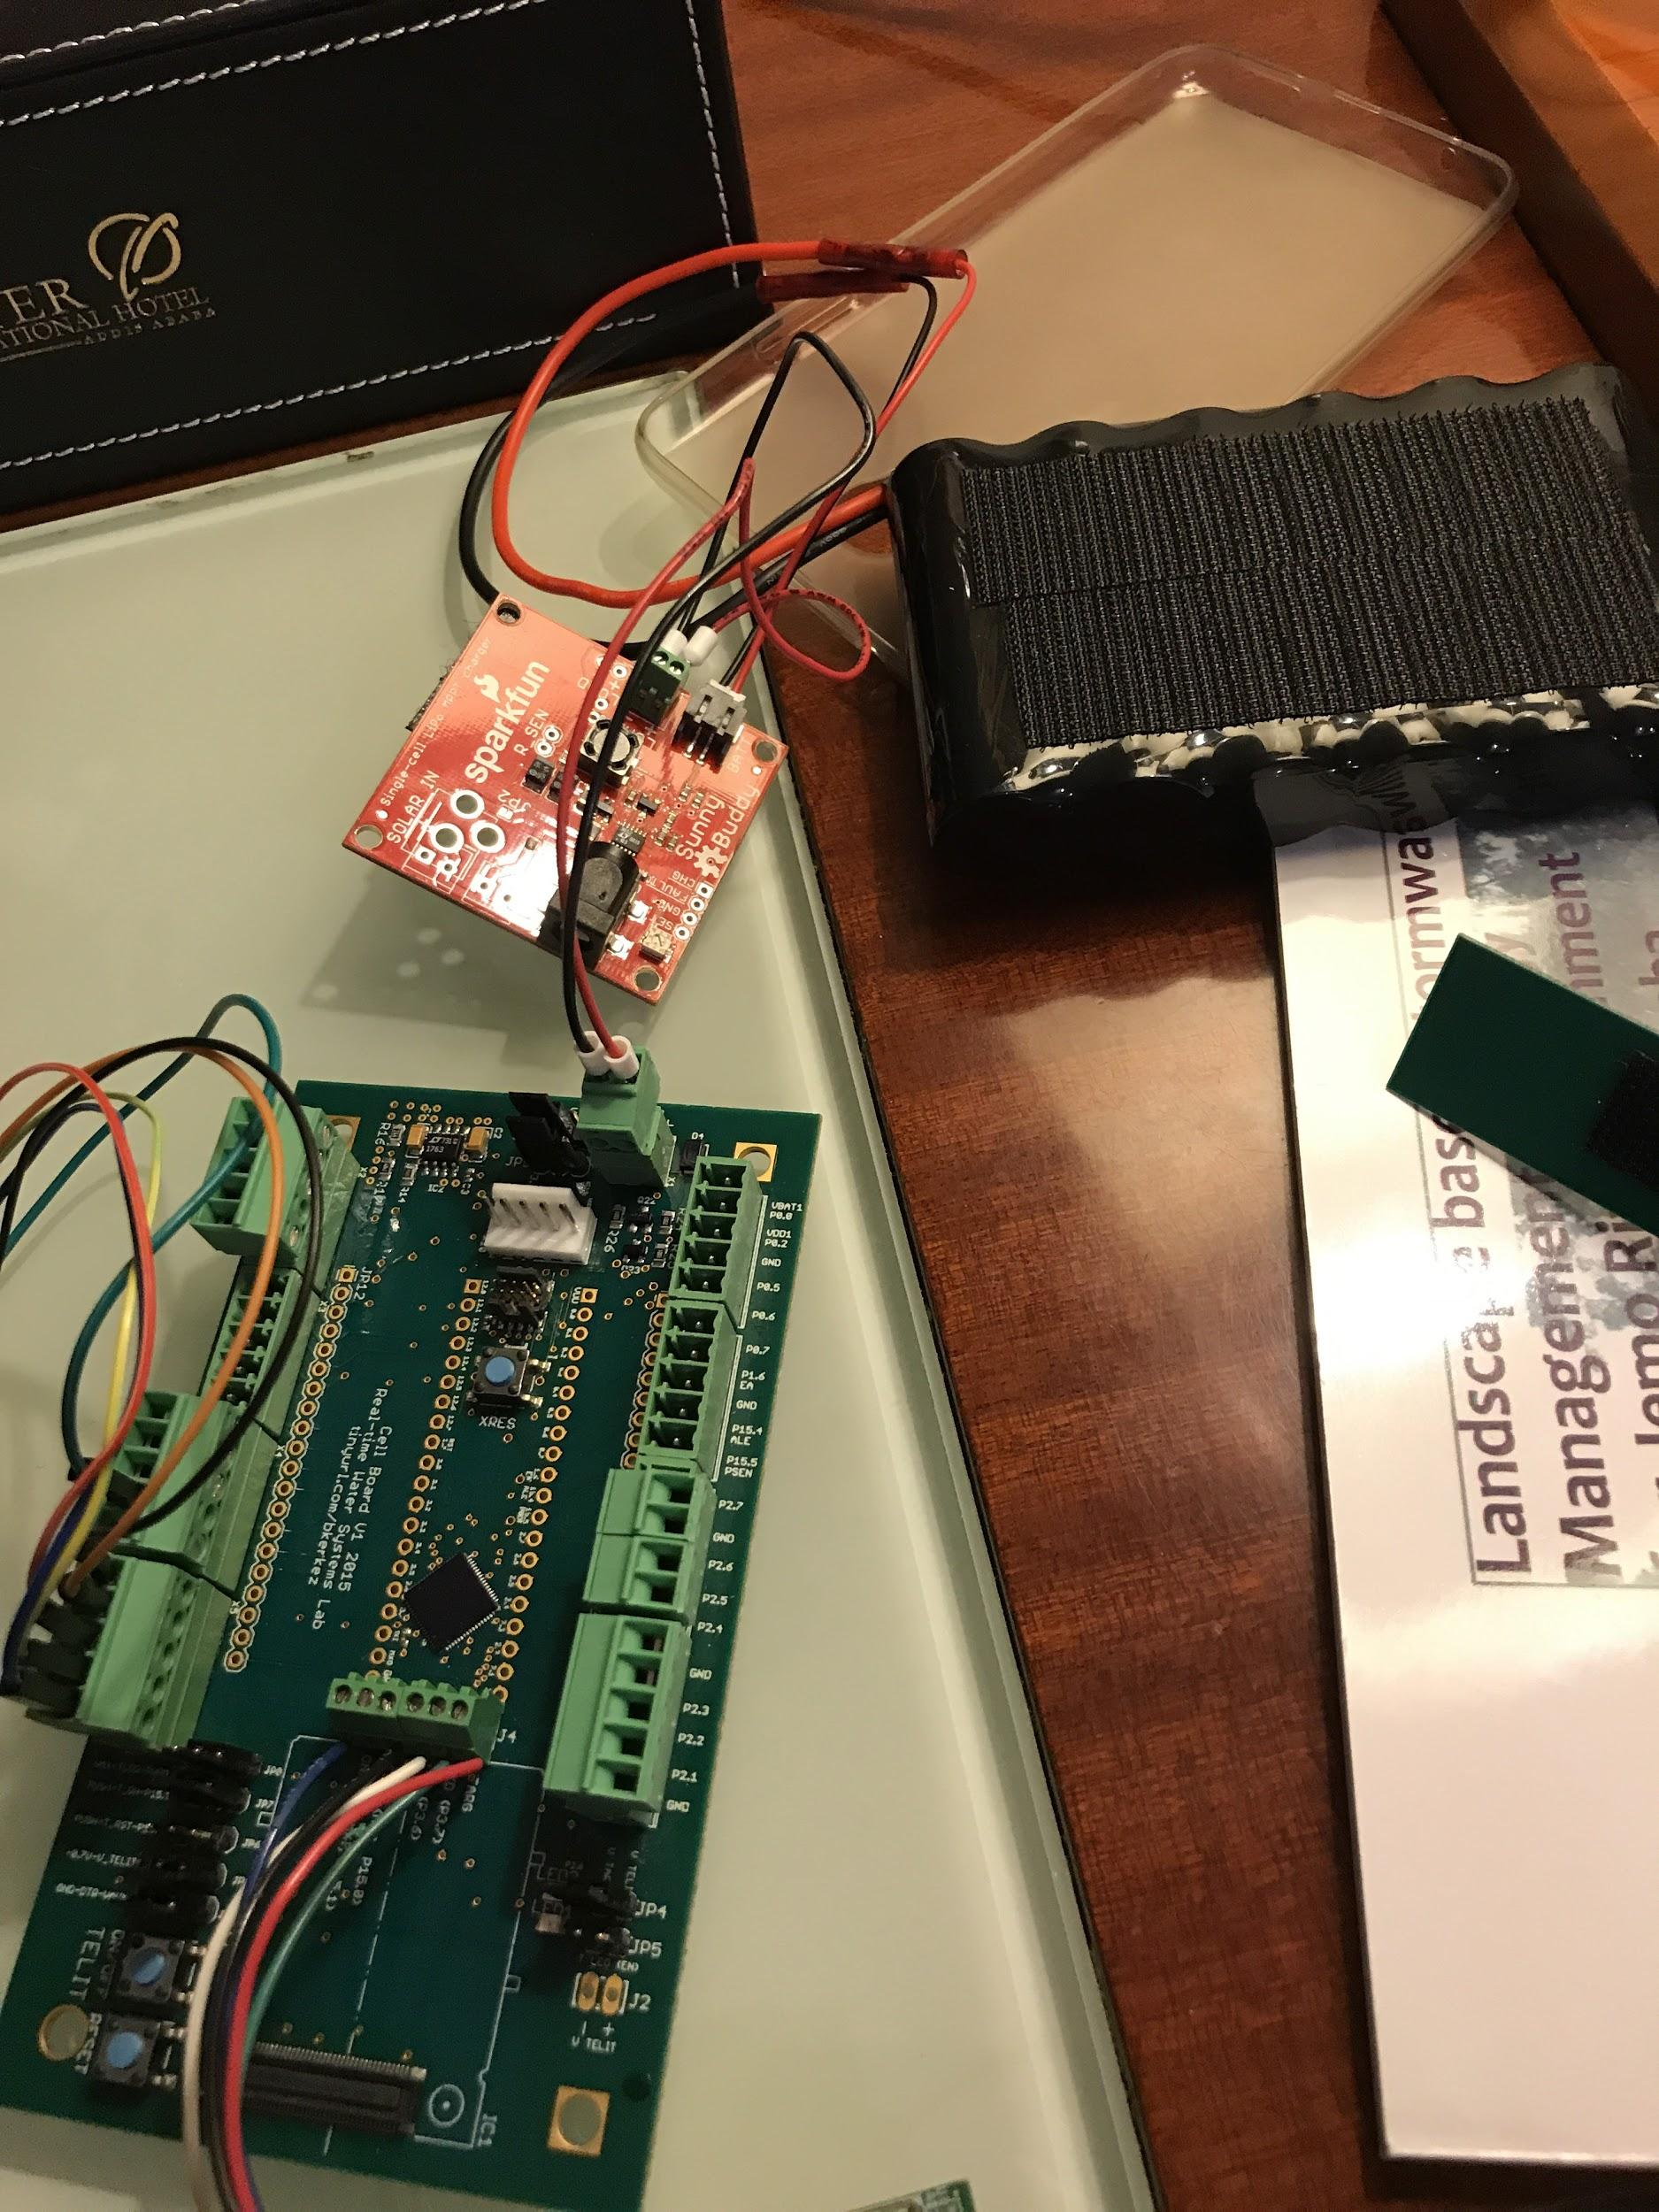

Flashing Firmware to Your Green Cellular Board

The opening screen of PSoC
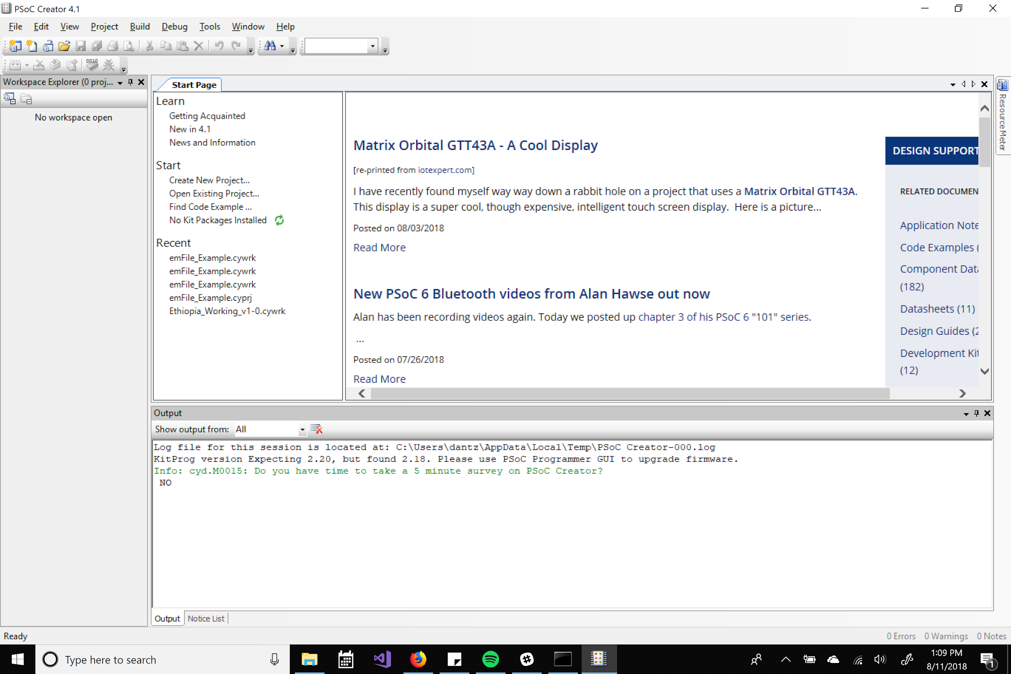
Go to file->open and find the project/workspace desired within your file structure
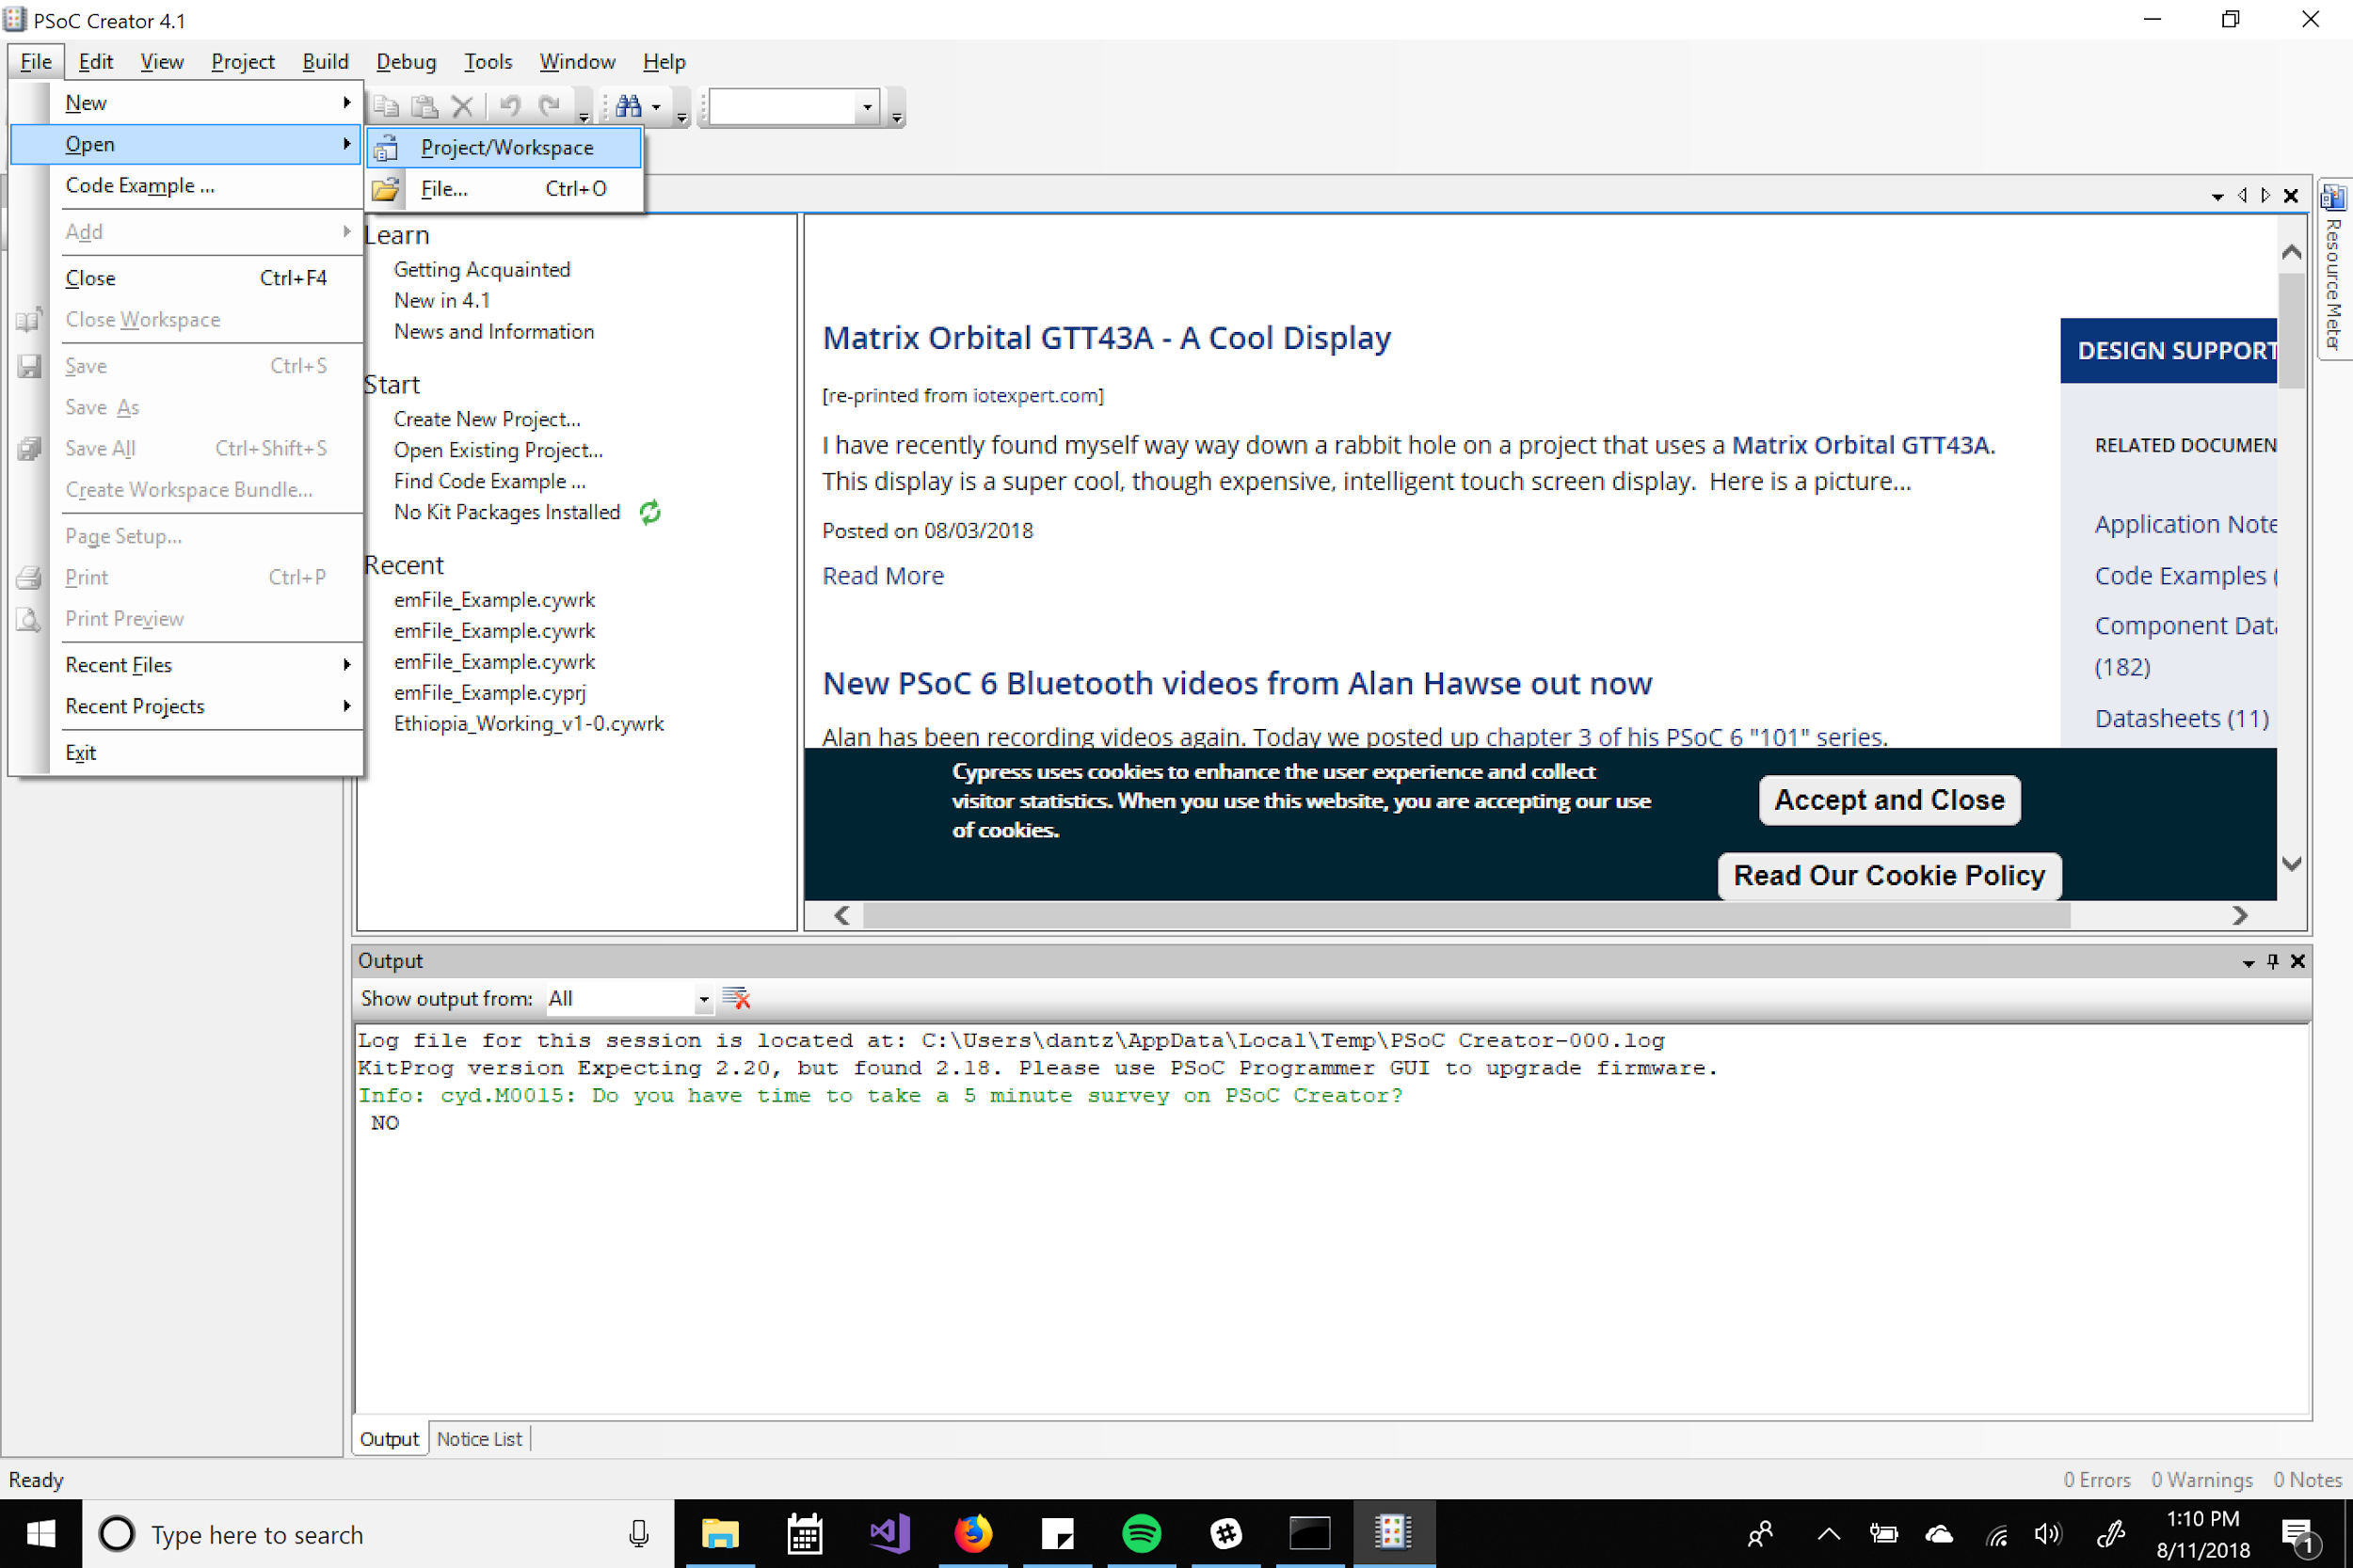
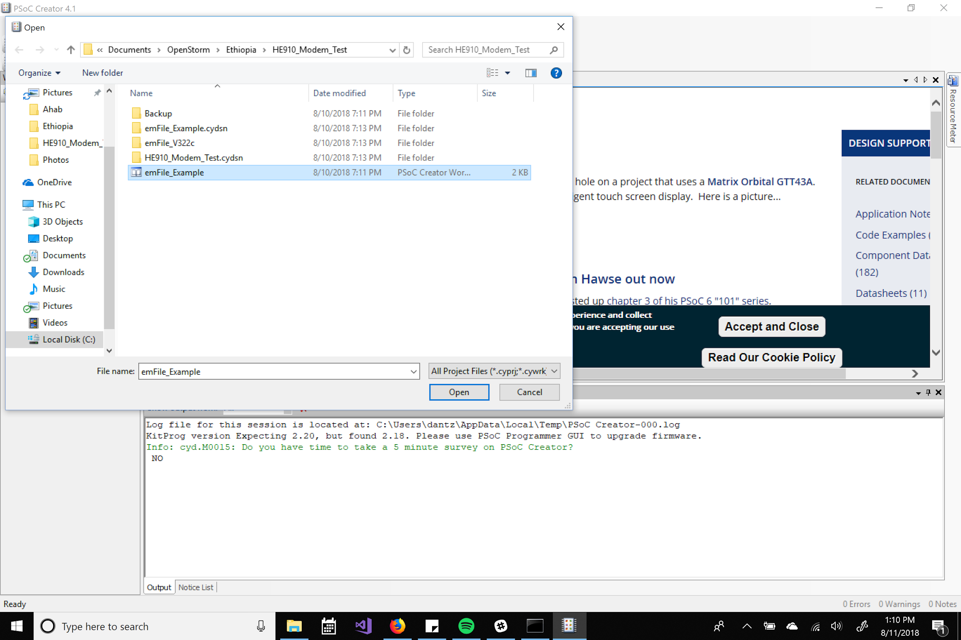

Nearly all the editing you do should be within the main.cc file
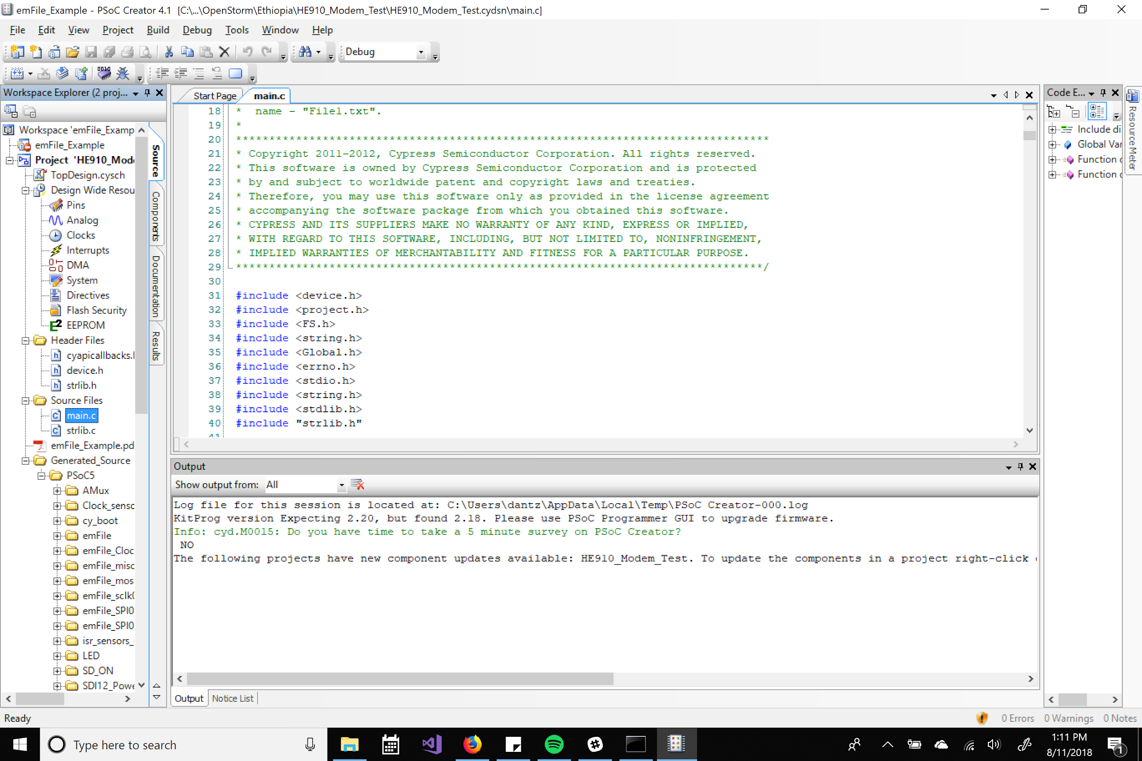
First build your project. If you get an error here you most likely don’t have “emFile_V322c” within your file path.
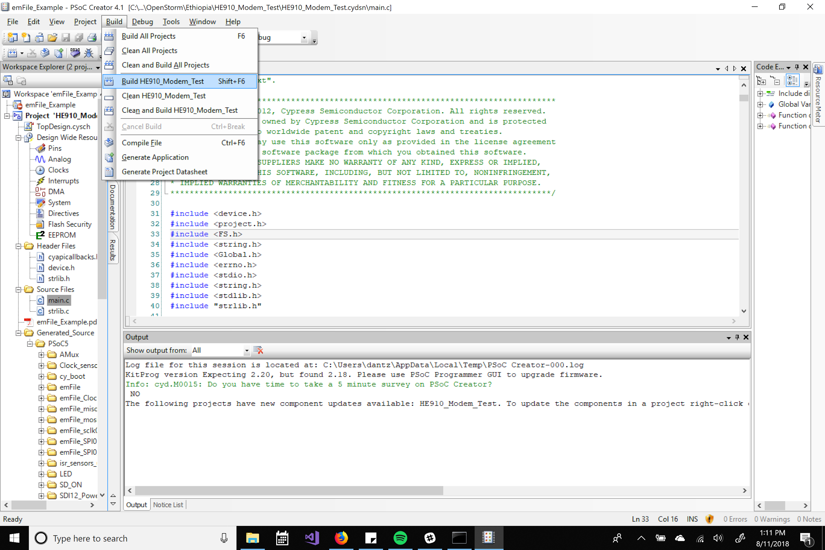
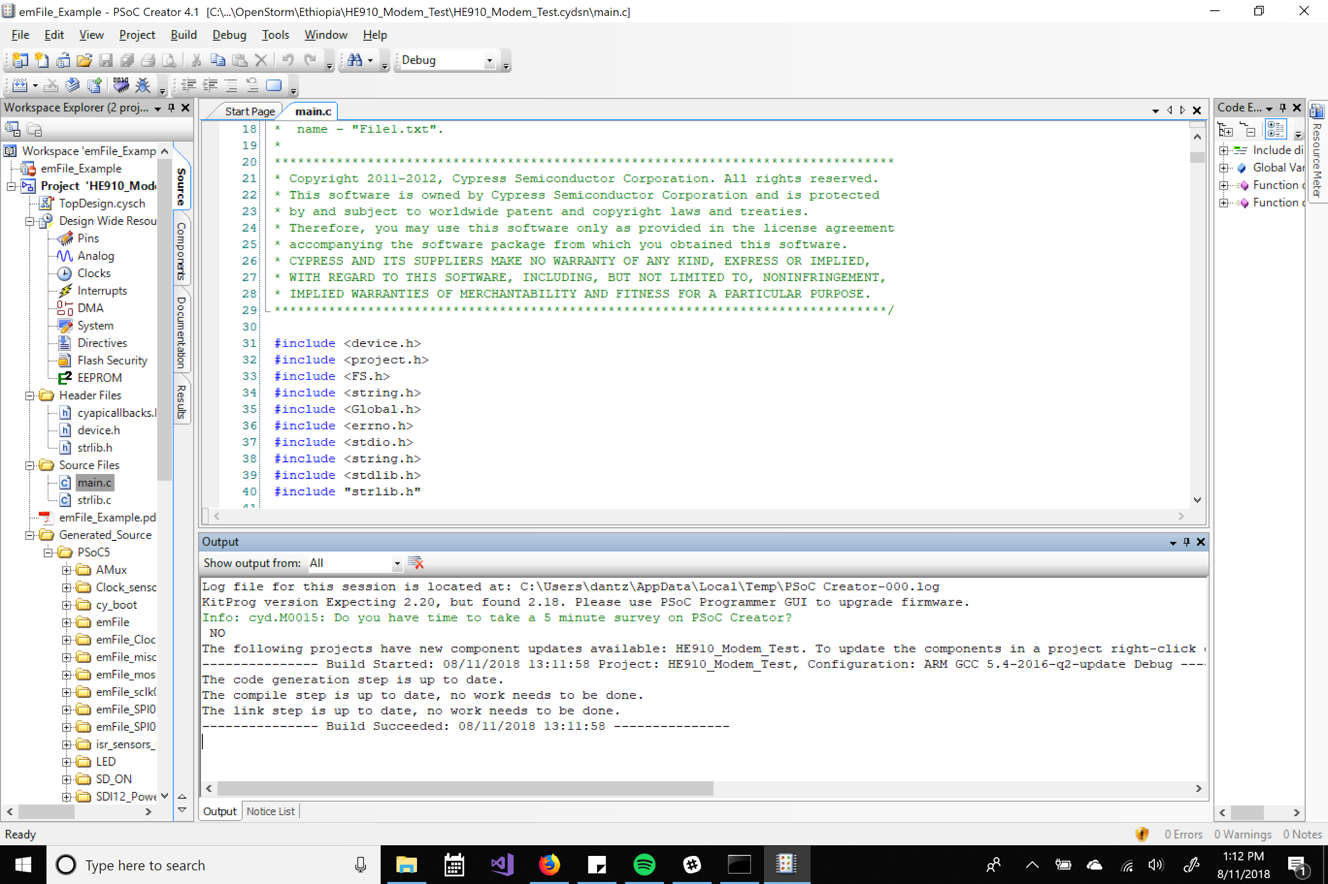
Plug the PSoC flasher into the white 5 pin debug port on your green board. Then select your debug target.
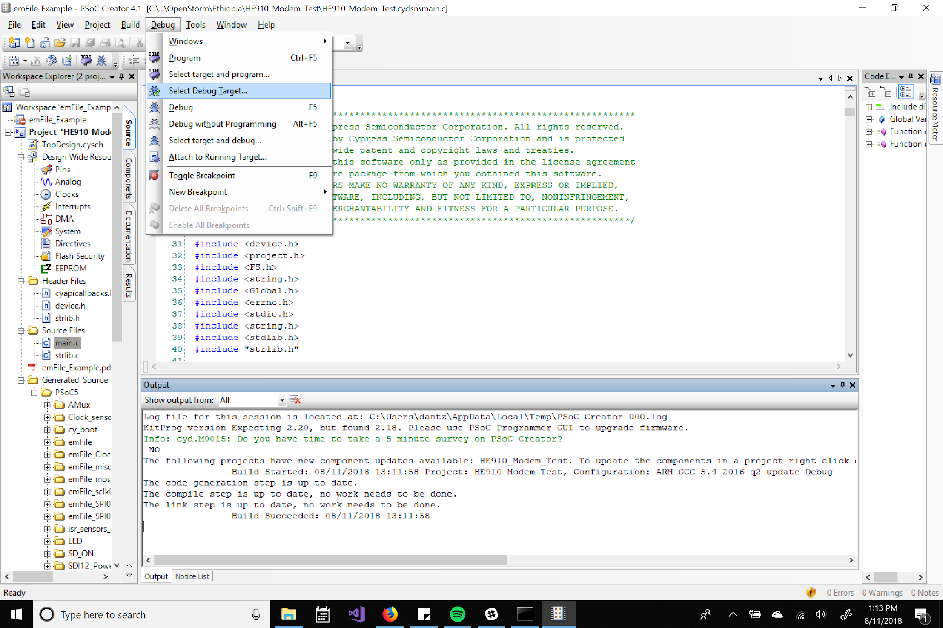
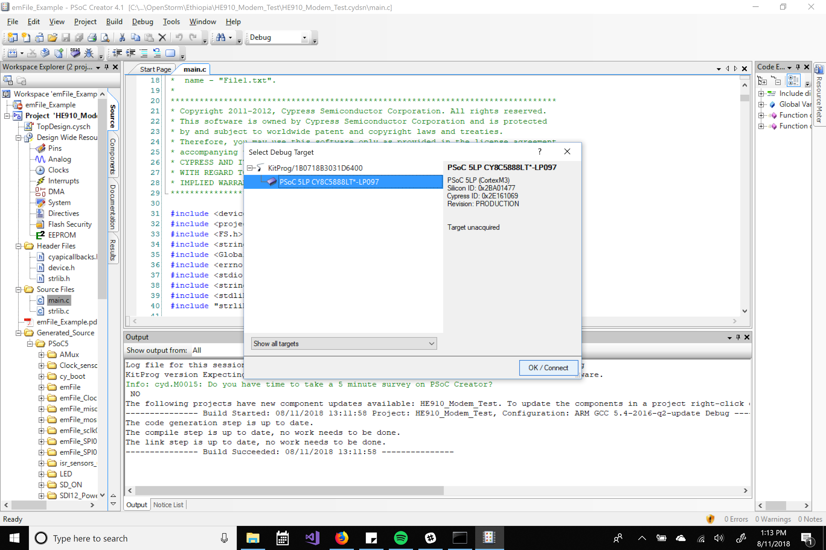
Then select program
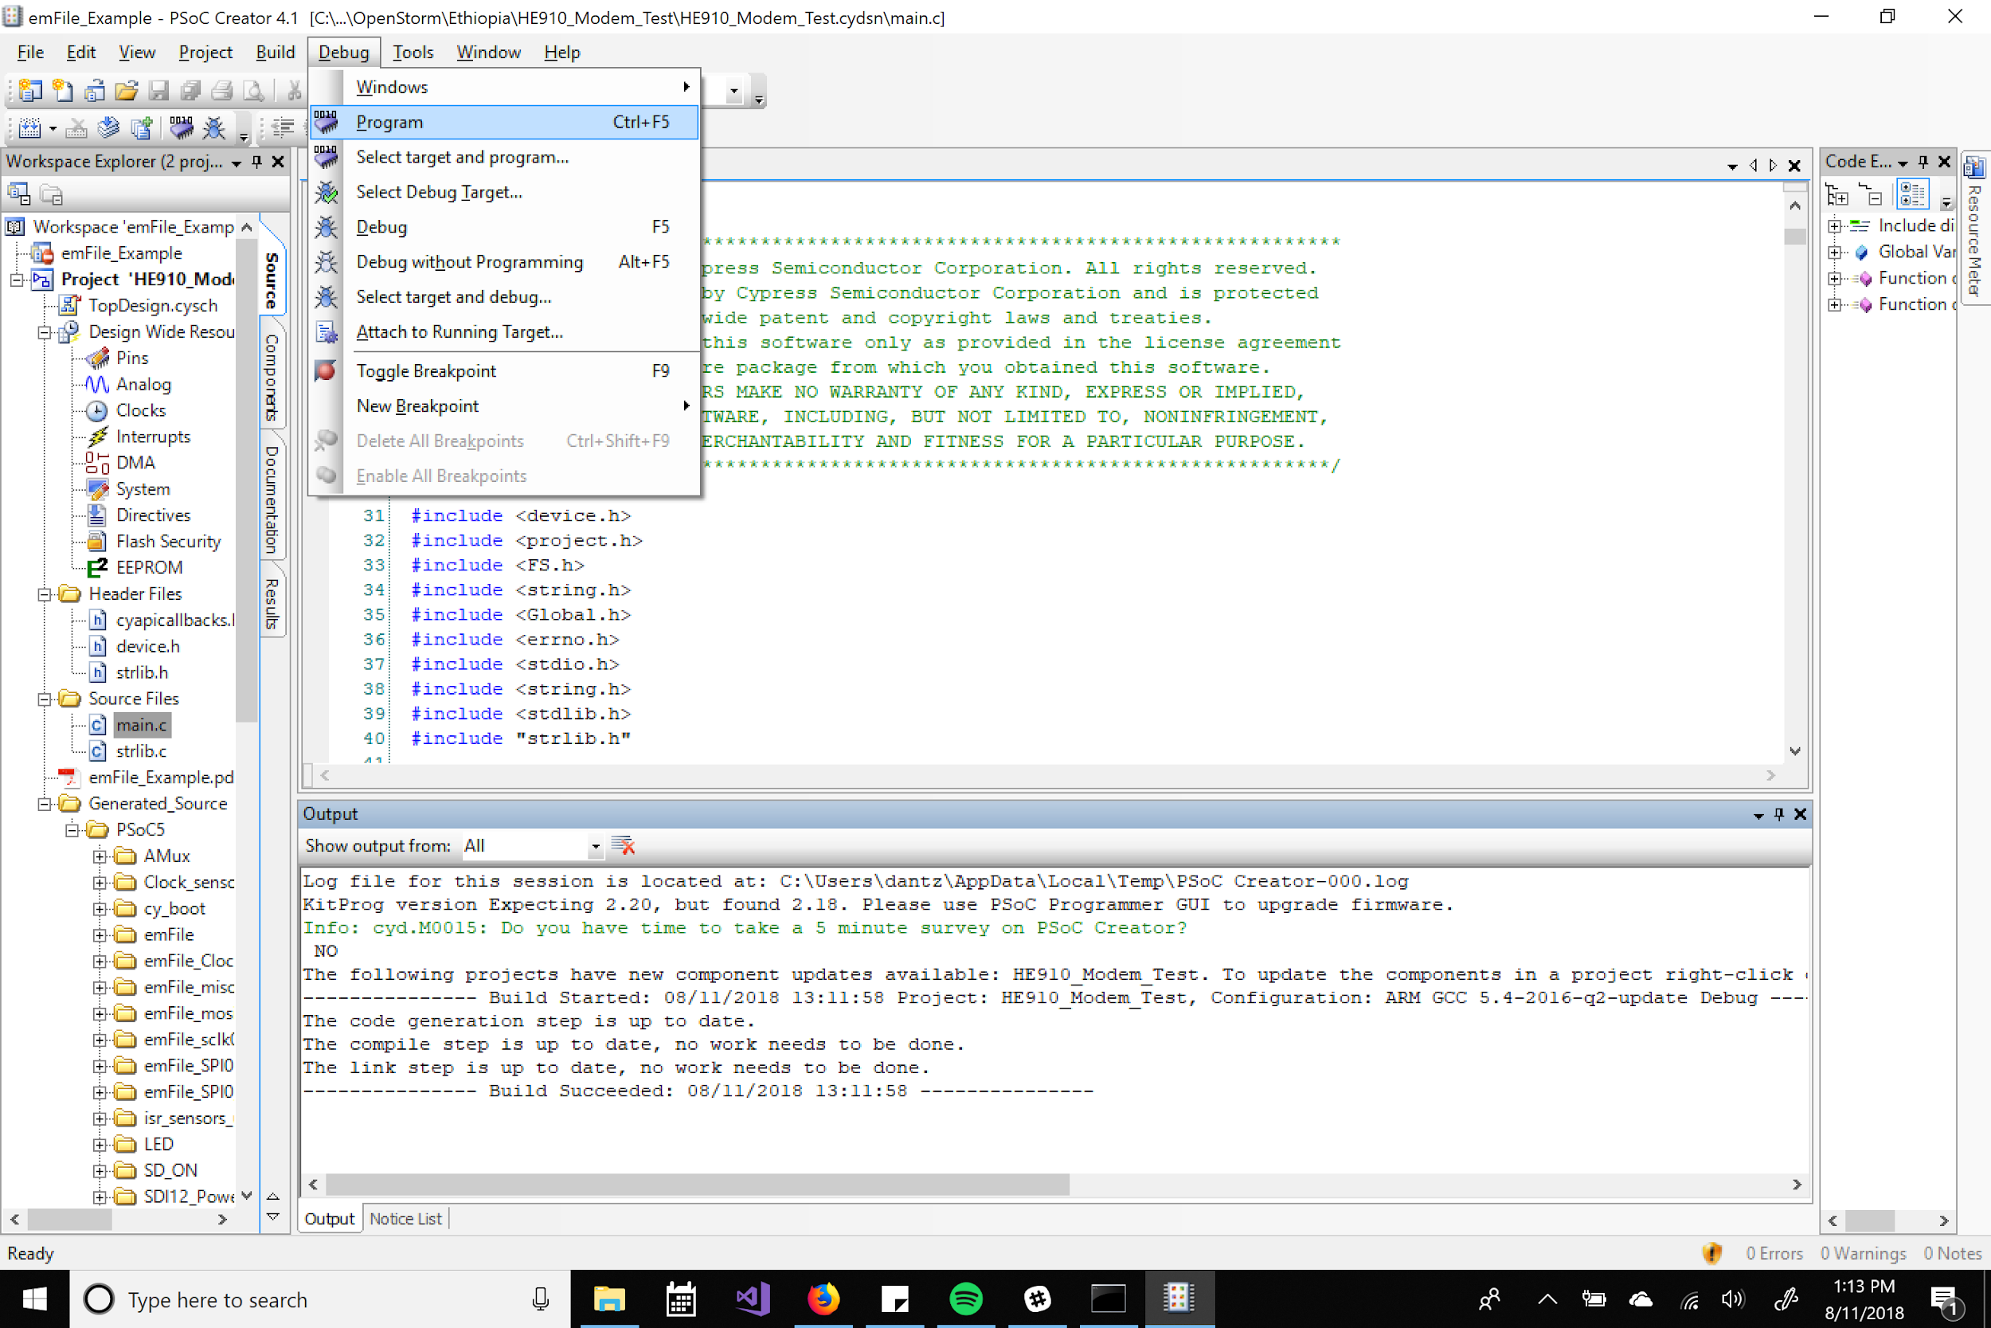
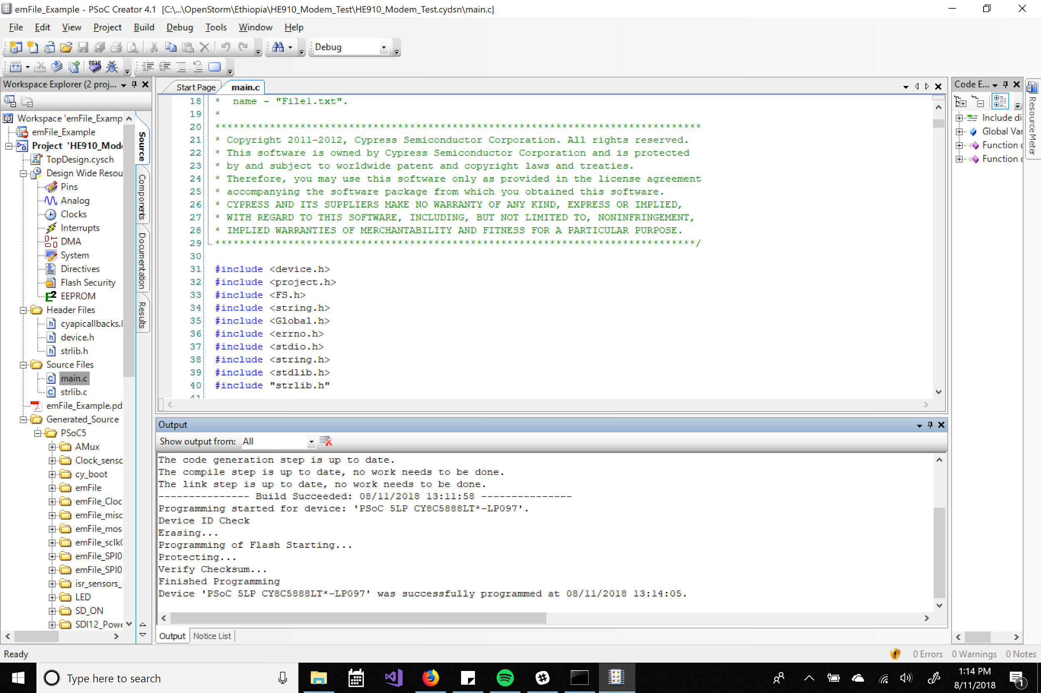Once the device is successfully programmed, remove the debug pin and run the board off battery power.

For the HE910 debug script a double LED flash every second will indicate the program has finished.

Debugging

Both programs will write debug statements to the micro SD card attached. View this within a phone, computer, or anything else than can view the .txt file. They should be within the ADD003 folder.

I recommend deleting all the files on the microSD before you put it back in to avoid clutter on the drive.

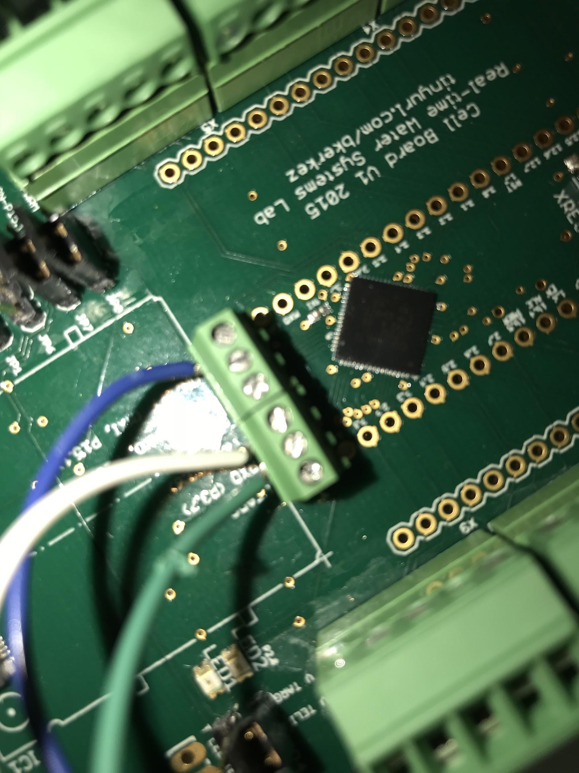
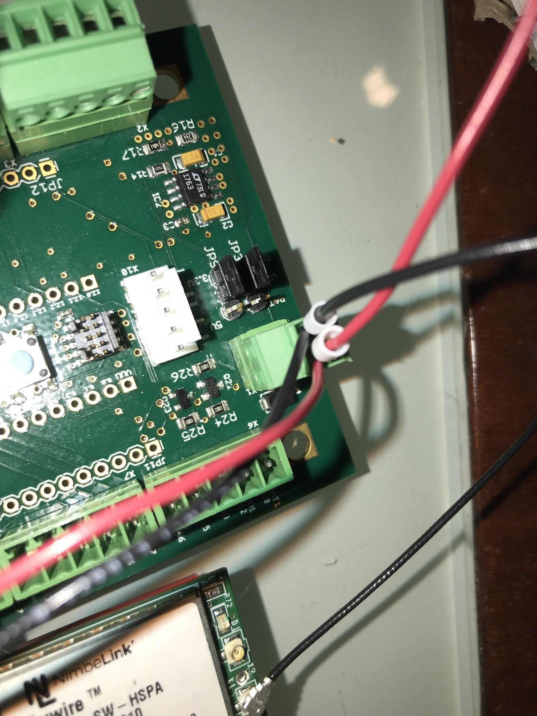
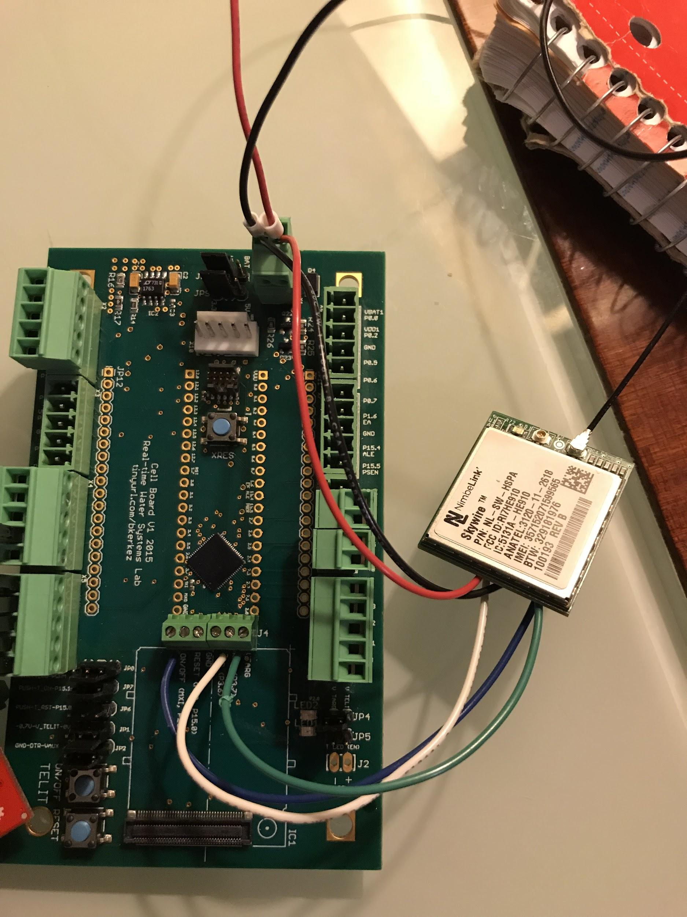
The larger sim card that fits within the GC864 cell modules is not activated and the programs are not written for these modules.

Wiring Schematics

Photon Board Wiring

Pressure Node

Depth Node

XBee Cell Module wiring

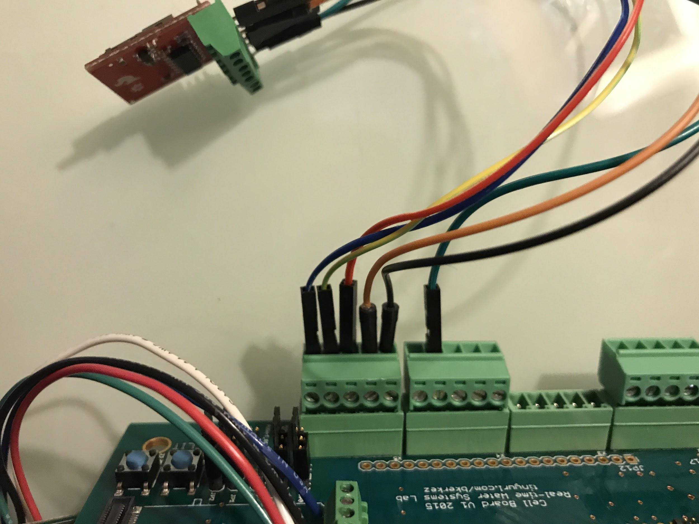

Micro SD wiring

In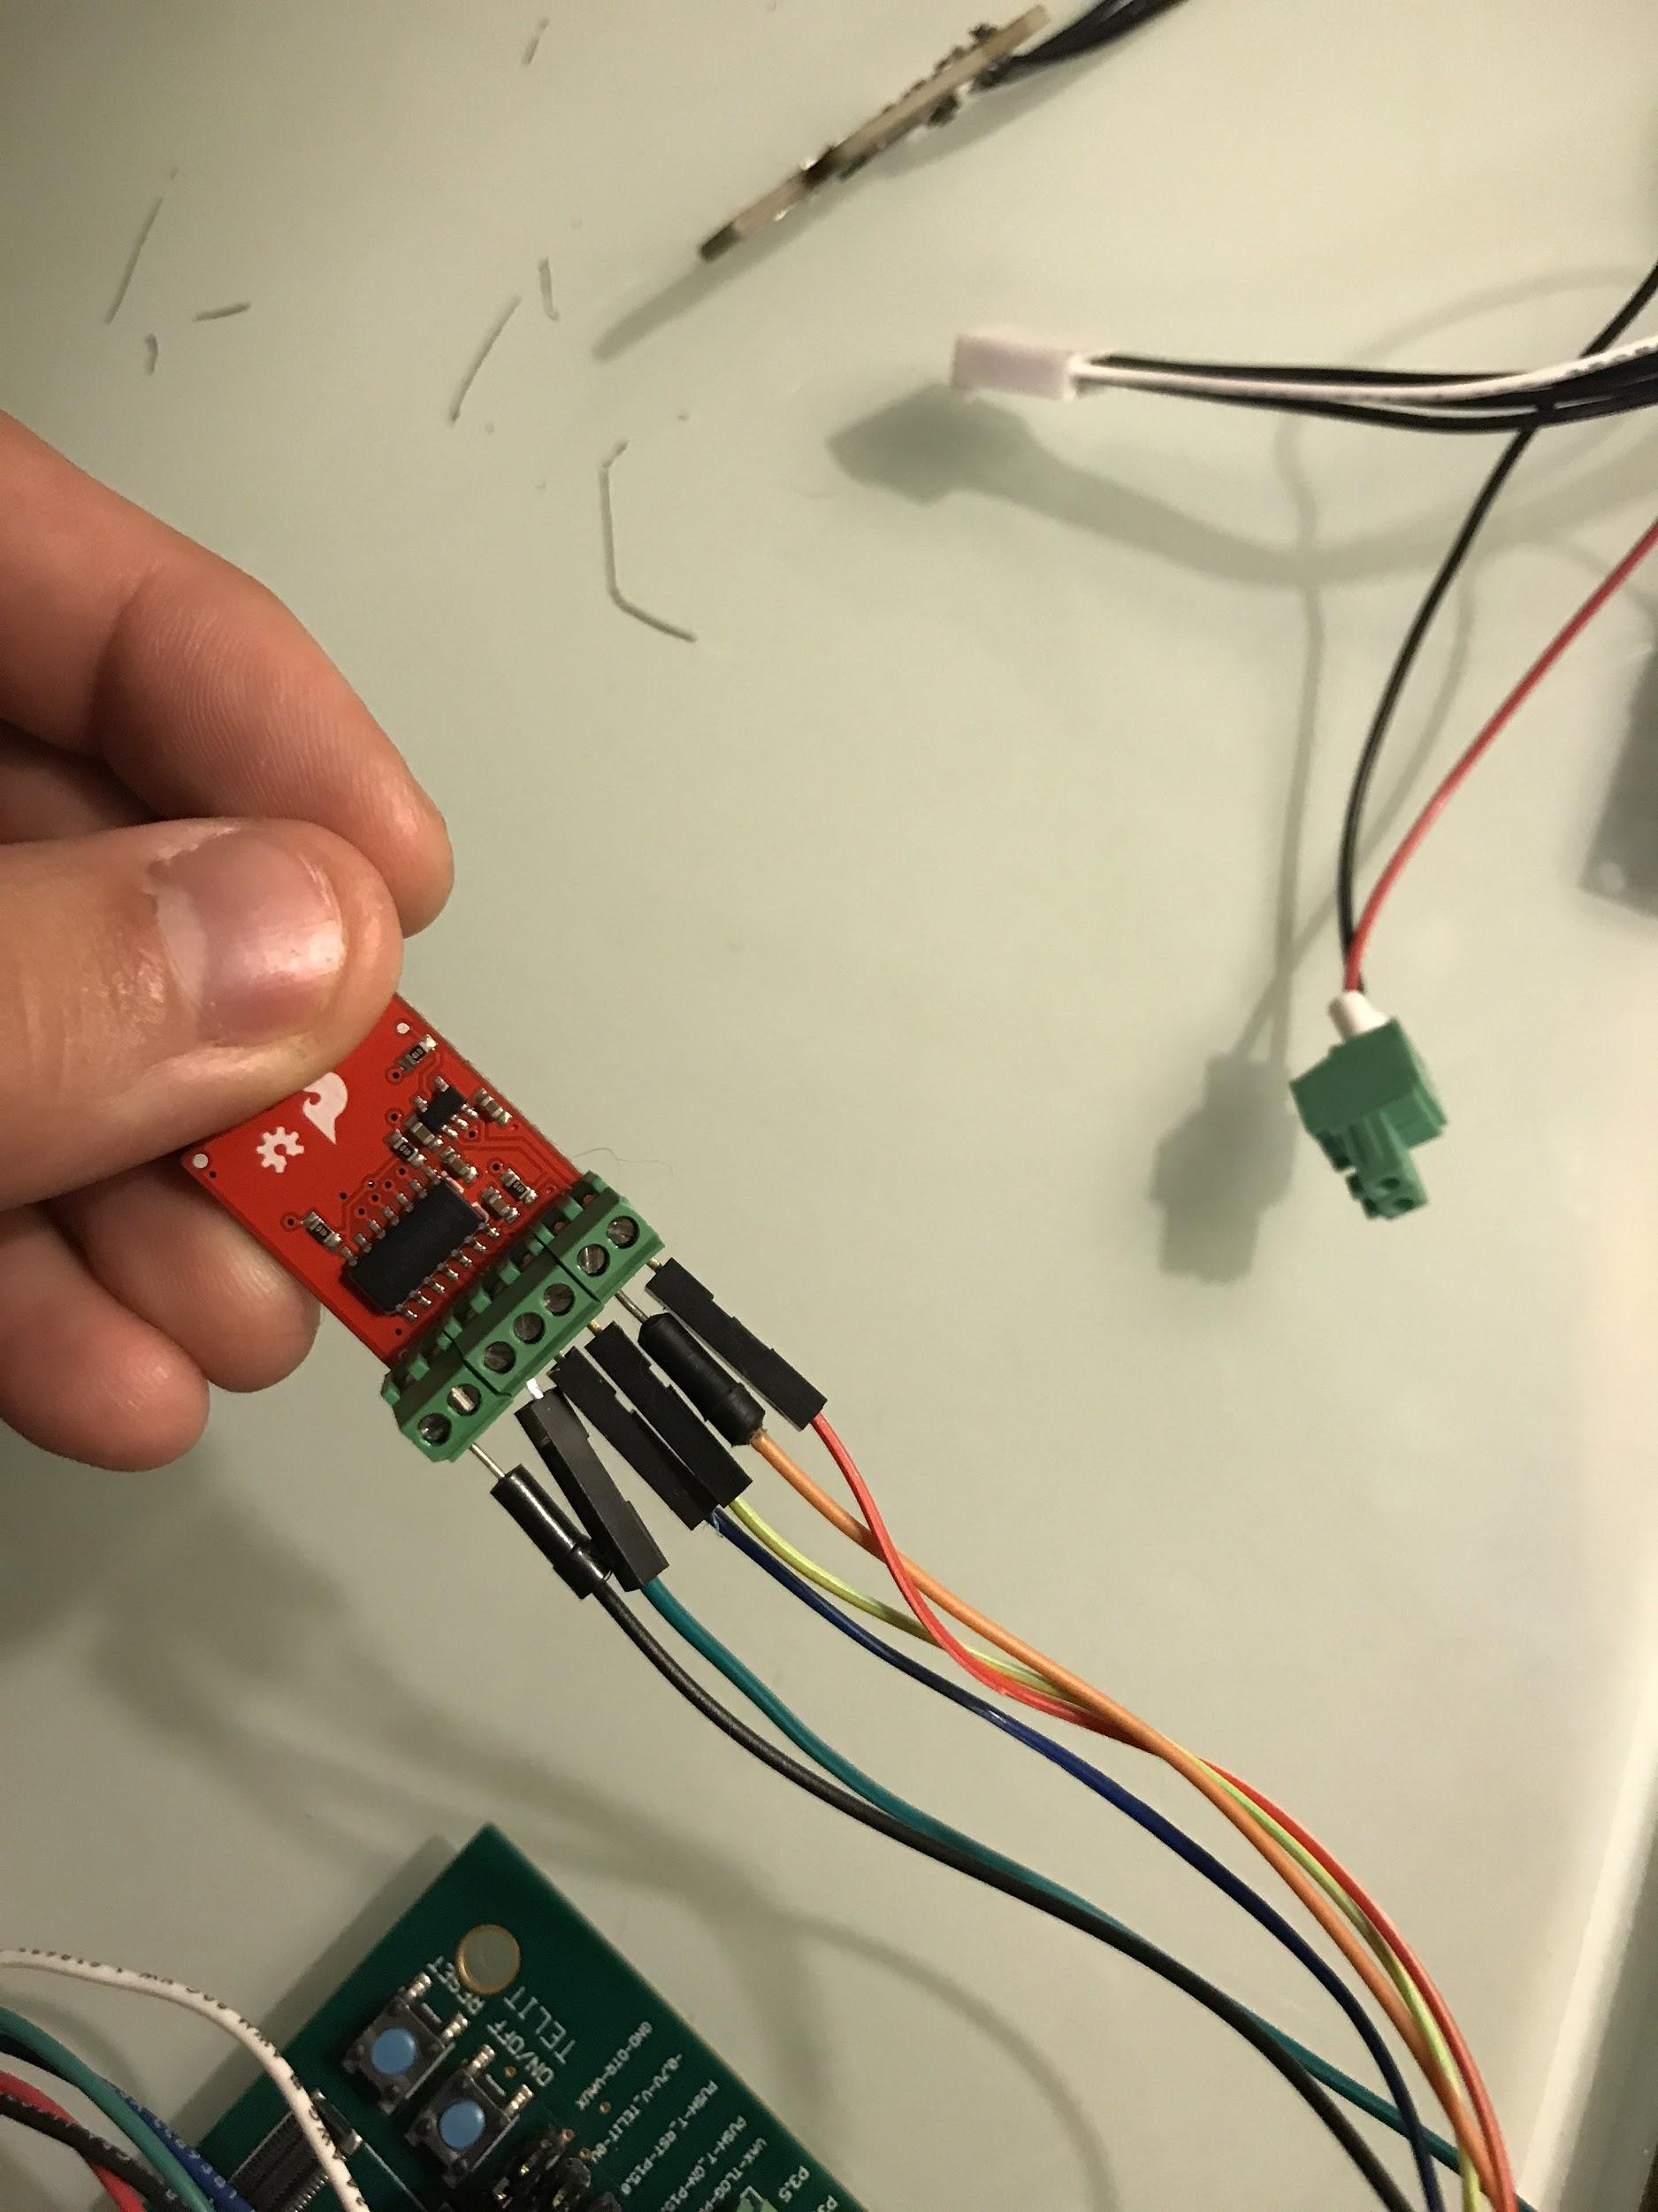
More details (measurements and schematics) in https://drive.google.com/file/d/1aZS3lqD1arz8thTdrpPpFyBLyrlujZN9/view?usp=sharing

SIM card for Cellular Pressure Node ADD003 is 094 429 6906

Josh -

Abi did most of the work setting up the grafana stream
Brandon would be the one to ask about the PSOC code

